**UNIVERSITI TUNKU ABDUL RAHMAN**



**Faculty of Information and Communication Technology**

**(FICT)**

**UCCD 2203 Database Systems**

**Session: 202001**

|  |  |  |  |  |  |
| --- | --- | --- | --- | --- | --- |
| No. | **Name** | **Student ID** | **Practical Group** | **Programme\*** | **Signature\*\*** |
| 1 | Lam Kean Chin | 17ACB05143 | P (7) | CS | signature.png |
| 2 | Tan Zhi Xuan | 17ACB03376 | P (8) | CS |  |
| 3 | Tan Jia Yong | 17ACB03508 | P (7) | CS |  |
| 4 | Leong Hong Xin | 17ACB04530 | P (7) | CS |  |
| 5 | Eddie H’ng Zheng Yan | 17ACB03421 | P (8) | CS |  |

* - IA/IB/CS/CN/CT

**All Students should attach the signed assessment sheet confirming that, the report is not plagiarized

**Marking Scheme**

|  |  |  |  |  |  |  |  |
| --- | --- | --- | --- | --- | --- | --- | --- |
| **PART 1: (Group Assessment - 50%)** | | | | | | | **Marks** |
| **1.** | **Scope of Work (5 marks)**  Analyse requirements study (briefly explain the requirements/ office / business rules in the system).  PLEASE INCLUDE ANY ASSUMPTIONS THAT YOU MAKE. | | | | | |  |
| **2.** | **ER model** (**10 marks**)  You are required to design an ER diagram for the case study given, identify entities, identify relationships, identify associate attribute and determine keys.  Check your ERD with the transaction requirements stated in the case. | | | | | |  |
| **3.** | **Redesign and EER** (**10 marks**)  Redesign your ER diagram with the new requirements and extending the ERD to EER model, if any. | | | | | |  |
| **4.** | **Data Dictionary** (**10 marks**)  Based on EER diagram that you created in part 4, create a data dictionary for the solution. (Make sure the data types (Oracle) selected are appropriate) | | | | | |  |
| **5.** | **Tables and records** (**5 marks**)  Create all relations in ERD and insert the necessary records (Minimum 5 record for each table) | | | | | |  |
| **6.** | **Script** (**10 marks**)  You are required to submit the SQL schema script with proper codes. Should include Integrity and referential integrity constraints.   |  | | --- | | **Softcopy:** *Include the script in CD* | | | | | | |  |
| **PART 1: Total Group Assessment - 50%** | | | | | | |  |
|  | | | | | | | |
| **PART 2: (Individual Assessment - 50%)**  (Filled in all your group members name and ID) | | | | | | | |
| **Student Name** | | **1. Eddie H’ng Zheng Yan** | **2.Tan Zhi Xuan** | **3. Leong Hong Xin** | **4. Lam Kean Chin** | **5. Tan Jia Yong** | |
| **Student ID** | | **17ACB03421** | **17ACB03376** | **17ACB04530** | **17ACB05143** | **17ACB03508** | |
| **Queries**  **(30 marks)** | |  |  |  |  |  | |
| **Stored**  **Procedure**  **(10 marks)** | |  |  |  |  |  | |
| **Function**  **(10 marks)** | |  |  |  |  |  | |
| **PART 2: Total Individual Assessment - 50%** | |  |  |  |  |  | |
| **PART 1 + PART 2**  **= 100%** | |  |  |  |  |  | |

**\*Minus 5 marks for no DVD/CD labelling (ALL members)**

**\*Minus 5 marks for not stapling the DVD/CD together with the assignment report. (ALL members)**

**\*Minus 10 marks for not printing out the marking scheme (ALL members)**

**(SAMPLE ONLY)TABLE OF CONTENTS**

1.0 Scope of Work………………………………………...…………….…………………………………………………….………....….1

1.1 Business Rule……………………………………………...………………………………………………………………….1

1.2 Requirements………………………………………………………………………………………………………………….2

2.0 ER Model…………………………….………...………………………………………………………………………………….…………4

3.0 Redesign and EER…………………………………………………………………………………………………………………………6

4.0 Data Dictionary………….…………………………………………………………..…………………………….……….….………...7

5.0 Tables and Records…………………………………………………..……………………………………………………...……….13

6.0 SQL script………………………………………………………………………………………………………….……………....………20

7.0 Individual Assessment (Eddie H’ng Zheng Yan, 17ACB03421)……………….…………………………...……..31

7.1 Queries……………………………………………………….………………………………………………………...……..31

7.2 Stored Procedure…………………………………………………………..……………………………………………..37

7.3 Function…………………………………………………………………………………………………………………..……47

8.0 Individual Assessment (Tan Zhi Xuan, 17ACB03376)………………………………………………………...……… 58

8.1 Queries………………………………………….………………………………………………………………………...…..58

8.2 Stored Procedure………………………………..………………………………………………………………………..68

8.3 Function…………………………………………………..………………………………………………………………...…78

9.0 Individual Assessment (Leong Hong Xin, 17ACB04530)………………………………………….………………….89

9.1 Queries…..………………………………………………….……………………………………………………………...…89

9.2 Stored Procedure…..……………………………………………………………………………………………..………98

9.3 Function…...…………………………………………………………………………………………………………..……109

10.0 Individual Assessment (Lam Kean Chin, 17ACB5143 )…………….…………………………………………......115

10.1 Queries……………………………………………………………………………………………………….…………….115

10.2 Stored Procedure……………………………………………………………………………………………..……….123

10.3 Function………………………………………………………………………………………………………..………….133

11.0 Individual Assessment (Tan Jia Yong, 17ACB03508 )…………………………………………………………......138

11.1 Queries……………………………………………………………………………………………………….…………….138

11.2 Stored Procedure…………………………………………………………………………………..………………….144

11.3 Function………………………………………………………………………………………………………..………….150

**1.0 Scope of Work:**

**1.1 Business rule**

1. Each branch can have one or more employees.

2. Each branch has one or more departments.

3. Each employee is assigned to one branch.

4. Each employee is allocated to one department.

5. Each employee is supervised by one manager.

6. Employees will be further grouped into full time employees and part time employees. Full time employee and part time employee is a subclass of employee; employee is the superclass.

7. Each Employee has an employee type.

8. Each employee has one or more leave balance records.

9. Each employee can submit one or many leave reports.

10. The Employees table record must have name, birthday date, hired date, marriage status, number of children age below 12 years old, identity card number for Malaysian and passport number for foreigner employee.

11. Each department can have at least one or many employees.

12. Each department only can have a branch.

13. Each employee type has one or many employees.

14. Each leave balance will record down each of the employee’s leave balance days.

15. A leave balance record is generated by a leave type table.

16. Each leave type will generate none or many leave balance records.

17. Each leave type can include with none or many leave reports.

18. Each leave report is for one employee.

19. Each leave report is included by one leave type.

20. Only the manager can change the leave status.

21. The number of balance days will be deducted once the leave is approved by the manager.

22. The employees can view back the previous leave history from the leave report.

23. Part time employees and trainees can take unpaid leave only.

**1.2 Requirements:**

First, the requirement of the system of company YY will be providing different types of leaves for example Annual Leave, Unpaid Leave, Sick Leave, Hospitalization Leave, Prolong Illness Leave, Examination Leave, Maternity Leave, Paternity Leave, Marriage Leave and Miscellaneous Leave. Each type of leave is defined as follows:

1. Annual Leave – 12 days of Annual Leave for each employee. Each year of the company starts from the 1st of January to the 31st of December
2. Unpaid leave - Applicable but that they are not paid for
3. Sick Leave – Applicable when the employee is sick but not hospitalised.
4. Hospitalization Leave – Applicable when the employee is hospitalized due to an accident/illness
5. Prolong Illness Leave - Employee suffering from a serious debilitating condition that will impair him/her from returning to work may be granted
6. Examination Leave – Applicable when the employee is sent out for an examination under the employee’s field of work. Examinations that are not under the employee’s scope of work are not applicable for the examination leave and should be registered instead as Unpaid Leave
7. Maternity Leave - Applicable only for a mother's absence from work before and after the birth of her child.
8. Paternity Leave - Applicable when a father wants to spend time with his new born baby.
9. Marriage leave - Applicable when the employee is getting married without loss of wages
10. Childcare leave- Applicable for working parents to look after their sick children which is aged below 12 years old.
11. compassionate leave- Applicable when a family member of an employee has passed away.
12. Miscellaneous leave - Employees who meet the definition of a regular employee may be eligible for leaves of absence, other than holiday, vacation, family and medical, parental, leave without pay, sick, and sick leave pool.

Other than that, each employee should only request for one type of leave in a single instance.

Company YY provides many types of leave. But there are certain types of leave that are only applicable when an employee has fully utilized the other leave type. Such as Unpaid Leave and Prolong Illness Leave. Unpaid Leave is applicable when Annual Leave is fully utilized. Prolong Illness Leave is applicable when Hospitalization Leave was fully utilized. Most of the employees leave type needs to be approved by the manager, but emergency leaves such as sick leave and hospitalization leave can be applied after the leaves are taken. Valid reasons need to be presented to the company when applying any types of leave.

In addition, some of the leave constraints are based on gender and marital status. For instance, only female employees can apply for maternity leave for 2 to 4 months. Hence, marriage leave is applicable for employees having the single status. Next, childcare leave is for employees who have at least one child. Each working parent gets six days of paid childcare leave annually.

All of the employees are given certain days to leave each year. In Company YY, new join employees have a total 12 days of leave each year. Once the new join employee works more than 5 years, the maximum leave of the employees increased to 14 days. All the leave will be unpaid after employees exceed the maximum number of days leave they have.

Employees are allowed to carry forward their days of Annual Leave that were not claimed by them in the previous year for up to 12 days in Annual Leave. Employees that have worked in the company for 5 years or more are only allowed to carry forward a maximum of 10 days of Annual Leave to the next year. Only the Annual Leave can be carried forward to the upcoming year for all employees.

**2.0 ER Model**

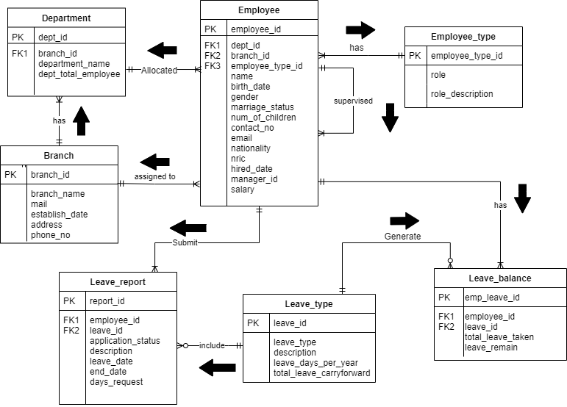

Employee

* employee_id(PK), dept_id(FK), branch_id(FK), employee_type_id(FK), name, birth_date, gender, marriage_status, num_of_children, contact_no, email, nationality, nric, hire_date, manager_id, salary

Employee_type

* employee_type_id(PK), role, role_description

Leave_balance

* emp_leave_id(PK), employee_id(FK), leave_id(FK) total_leave_taken, leave_remain

Department

* dept_id(PK), branch_id(FK), department_name, dept_total_employee

Branch

* branch_id(PK), branch_name, mail, established_date , address, phone_no

Leave Reports

* report_id(PK), employee_id(FK), leave_id(FK), application_status, description, leave_date, end_date, days_request

Leave Type

* leave_id(PK), leave_type, description, leave_days_per_year, total_leave_carryforward

**3.0 Redesign and EER**

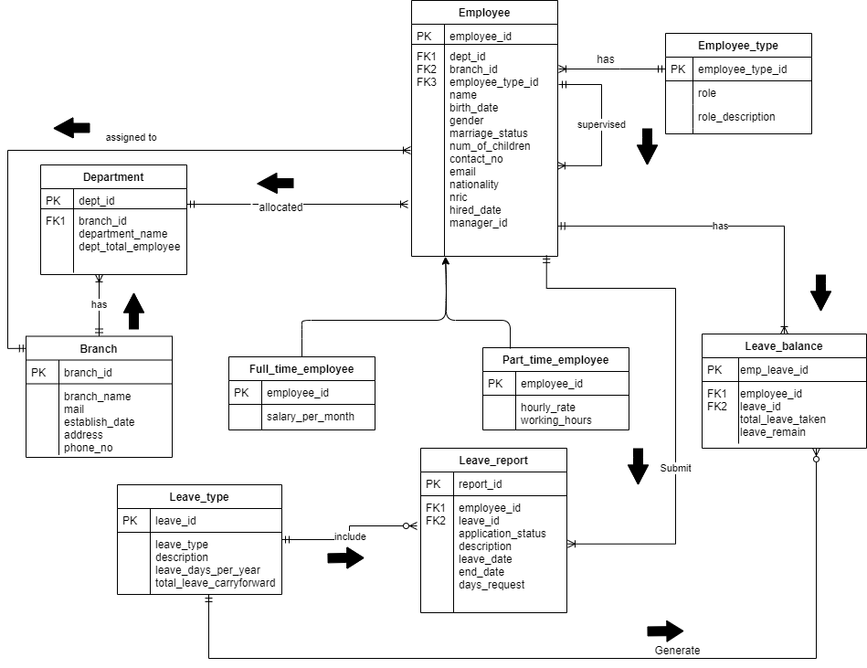

**4.0 Data dictionary for entity type**

|  |  |  |  |
| --- | --- | --- | --- |
| Entity Name | Description | Aliases | Occurrence |
| Employee | General term describing employee details of the Company | Employee | Each member of staff works at one particular department |
| Employee_type | General terms describing the role and description of the employee in the Company. | Role | Each employee works at what position and the details of the position. |
| Department | General term describing the details of the department of the Company | Department | Each department will have one or more employees included in it. |
| Branch | General terms describing the details of the Branch of the Company. | Branch | Each branch is under the same Company that works in a different location. |
| Leave_report | General term describing the details of the leave request in the report form. | Leave Request Report | Each leave request will be stored in a report form whenever an employee tries to take leave. |
| Leave_type | General term describing the leave type of the employee chosen to take. | Type of Leave | Each type of leave can be taken once the requirement is fulfilled. |
| Leave_balance | General term describing the leave balance of the employee. | Leave Balance | Each leave balance recording the number of leaves can be taken by the employee. |

**Data dictionary for relationship type**

|  |  |  |  |
| --- | --- | --- | --- |
| Entity Name | Relationship | Entity Name | Multiplicity |
| Employees | Has | Employee_type | 1..1 |
|  | Allocated | Department | 1..1 |
|  | Assigned to | Branch | 1..1 |
|  | Supervised | Employees | 1..* |
|  | Own | Leave_balance | 1..* |
|  | Request | Leave_report | 1..* |
| Employee_type | Has | Employees | 1..* |
| Department | Allocated | Employees | 1..* |
|  | Has | Branch | 1..1 |
| Branch | Has | Department | 1..* |
|  | Has | Employees | 1..* |
| Leave_report | Request by | Employees | 1..1 |
|  | Include by | Leave_type | 1..1 |
|  | Has | Leave_balance | 1..1 |
| Leave_type | Include | Leave_report | 0..* |
|  | Generate | Leave_balance | 0..* |
| Leave_balance | Own by | Employees | 1..1 |
|  | Generate By | Leave_type | 1..1 |
| Full_time_employees | Is A | Employees | - |
| Part_time_employees | Is A | Employees | - |

**Data dictionary for attribute**

Employees table attributes

|  |  |  |  |  |  |  |  |  |
| --- | --- | --- | --- | --- | --- | --- | --- | --- |
| Attribute | Description | Data Type | Size | Null | Multi  Value | PK/FK | Reference To | Example Data |
| employee_id | Unique identifies employees | varchar2(8) | 8 | No | No | PK | - | A10001 |
| dept_id | Unique identifies department | varchar(3) | 3 | No | No | FK | department(department_id) | A1 |
| branch_id | Unique identifies branch | varchar(2) | 2 | No | No | FK | branch(branch_id) | A |
| employee_type_id | Unique identifies employee type id | varchar(3) | 3 | No | No | FK | employee_type(employee_type_id) | 1 |
| name | Name of employee | varchar(50) | 50 | No | No | - | - | Lam Kean Chin |
| birth_date | Birth date of employee | date | 10 | No | No | - | - | 2020-03-29 |
| gender | Gender of employee | varchar(1) | 1 | No | No | - | - | M |
| marriage_status | Marriage status of employee | varchar(10) | 10 | No | No | - | - | Single |
| num_of_children | Number of children which age below 12 years old | int | 1 | No | No | - | - | 0 |
| contact_no | Contact number of employee | varchar(12) | 12 | Yes | Yes | - | - | 010-2335463 |
| email | Email of employee | varchar(60) | 60 | Yes | No | - | - | keanchin980516@gmail.com |
| nationality | Nationality of employee | varchar(20) | 20 | No | No | - | - | Malaysia |
| nric | Identity number of employee | varchar(20) | 20 | No | No | - | - | 980516-08-6455 |
| hired_date | Date of employee hired by company | date | 10 | No | No | - | - | 2018-10-10 |
| manager_id | Show the employee’s manager | varchar(8) | 8 | Yes | No | - | - | A10003 |
| salary | Salary per month of employee | Number(8,2) | 8 | No | No | - | - | 10000 |

Employee type attributes

|  |  |  |  |  |  |  |  |  |
| --- | --- | --- | --- | --- | --- | --- | --- | --- |
| Attribute | Description | Data Type | Size | Null | Multi  Value | PK/FK | Reference To | Example Data |
| employee_type_id | Unique identifies employee type id | varchar(3) | 3 | No | No | PK | - | 1 |
| role | Employee’s role name in the company | varchar(30) | 30 | No | No | - | - | Software developers |
| role_description | Employee’s role description in the company | varchar(255) | 255 | Yes | No | - | - | Software developers create applications on database, operating system and software |

Department attributes

|  |  |  |  |  |  |  |  |  |
| --- | --- | --- | --- | --- | --- | --- | --- | --- |
| Attribute | Description | Data Type | Size | Null | Multi  Value | PK/FK | Reference To | Example Data |
| dept_id | Unique identifies department | varchar(3) | 3 | No | No | PK | - | A1 |
| branch_id | Unique identifies branch | varchar(2) | 2 | No | No | FK | branch(branch_id) | A |
| dept_name | Name of the department | varchar(50) | 50 | No | No | - | - | Security Department |
| dept_total_employee | Total employees contain in the department | int | 4 | No | No | - | - | 12 |

Branch attributes

|  |  |  |  |  |  |  |  |  |
| --- | --- | --- | --- | --- | --- | --- | --- | --- |
| Attribute | Description | Data Type | Size | Null | Multi  Value | PK/FK | Reference To | Example Data |
| branch_id | Unique identifies branch | varchar(2) | 2 | No | No | PK | - | A |
| name | Name of branch | varchar(50) | 50 | No | No | - | - | Phoenix Ipoh |
| email | Email use for the branch | varchar(60) | 60 | No | No | - | - | phoenixA@gmail.com |
| establish_date | Date of the branch start working | date | 10 | No | No | - | - | 16/05/2018 |
| address | Exact location of the branch | varchar(255) | 255 | No | No | - | - | 237,Jalan Tai Fi Tong,30010 Ipoh Perak |
| phone_no | Phone number that use by the branch | varchar(12) | 12 | No | Yes | - | - | 03-2335463 |

Leave Report attributes

|  |  |  |  |  |  |  |  |  |
| --- | --- | --- | --- | --- | --- | --- | --- | --- |
| Attribute | Description | Data Type | Size | Null | Multi  Value | PK/FK | Reference To | Example Data |
| report _id | Unique identifies report | number(5) | 5 | No | No | PK | - | 1234 |
| employee_id | Unique identifies employees | varchar(6) | 6 | No | No | FK | employees(employee_id) | A00001 |
| leave_id | Unique identifies leave_type | number(3) | 3 | No | No | FK | leave_type(leave_id) | 11 |
| application_status | Show the request pass(approved) or fail(forfeited) | varchar(9) | 9 | No | No | - | - | approved |
| description | Description wrote by the employee for the leave request | varchar(255) | 255 | Yes | No | - | - | Celebrate Chinese Christmas |
| leave_date | Date that employee start leave | date | 10 | No | No | - | - | 16/05/2020 |
| end_date | Date that employee need to be come back tomorrow | date | 10 | No | No | - | - | 20/05/2020 |
| days_request | Number of days request to leave | number(3) | 3 | No | No | - | - | 5 |

Leave Type attributes

|  |  |  |  |  |  |  |  |  |
| --- | --- | --- | --- | --- | --- | --- | --- | --- |
| Attribute | Description | Data Type | Size | Null | Multi  Value | PK/FK | Reference To | Example Data |
| leave_id | Unique identifies leave type | number(3) | 3 | No | No | PK | - | 1 |
| leave_type | Name of the leave type | varchar(50) | 50 | No | No | - | - | Sick Leave |
| description | Description of the leave type | varchar(255) | 255 | Yes | No | - | - | Guarantee workers [paid time off](https://en.wikipedia.org/wiki/Paid_time_off) to stay home when they are sick |
| leave_days_per_year | Total leave per year of an employee | number(3) | 3 | Yes | No | - | - | 12 |
| max_days_carryforward | The max day leave that can carry forward to the next year | number(2) | 2 | No | No | - | - | 10 |

Leave Balance attributes

|  |  |  |  |  |  |  |  |  |
| --- | --- | --- | --- | --- | --- | --- | --- | --- |
| Attribute | Description | Data Type | Size | Null | Multi  Value | PK/FK | Reference To | Example Data |
| emp_leave_id | Unique identifies leave balance record | number(5) | 5 | No | No | PK | - | 109 |
| employee_id | Unique identifies employees | varchar2(6) | 6 | No | No | FK | employees(employee_id) | A00001 |
| leave_id | Unique identifies leave type | number(3) | 3 | No | No | FK | leave_type(leave_id) | 11 |
| total_leave_taken | Total leave took by employee | number(2) | 2 | YES | No | - | - | 4 |
| leave_remain | The remaining leave that can be took by employee | number(3) | 3 | YES | No | - | - | 6 |

**5.0 Tables and Records**

Employee

|  |  |  |  |  |  |  |  |  |  |  |  |  |  |  |  |  |
| --- | --- | --- | --- | --- | --- | --- | --- | --- | --- | --- | --- | --- | --- | --- | --- | --- |
| employee_id | dept_id | branch_id |  | employee_type_id | name | birth_date | gender | marriage_status | num_of_children | contact_no | email | nationality | nric | hired_  date | manager_id | Salary |
| A10000 | B1 | B |  | 1 | Lee Jiu Zhe | 1990-03-25 | 'M' | 'Single' | 0 | 012-1122335 | jiuzhe90@gmail.com | Malaysia | 900325-01-1234 | 2014-03-16 | A10004 | 5000 |
| A10001 | B1 | B |  | 2 | 'Ooi hong goh' | 1987-01-11 | M | 'Single' | 0 | 011-3216548 | honggoh87@gmail.com | Malaysia | 870111-02-1122 | 2018-03-16 | A10004 | 4500 |
| A10002 | B1 | B |  | 3 | 'Ng Xiang Wei' | 1991-09-27 | F | 'Single' | 0 | 012-5114489 | xiangwei91@gmail.com | Korea | 910927-05-5566 | 2014-05-24 | A10003 | 10000 |
| A10003 | B1 | B |  | 6 | Lee Ting Wei | 1988-06-24 | F | Single | 0 | 013-5266854 | tingwei88@gmail.com | China | 880624-09-6541 | 2013-03-16 |  | 50000 |
| A10004 | B1 | B |  | 4 | Henry Tan | 1993-12-25 | M | Married | 5 | 010-9879878 | henry1199@ggmai.coc | Malaysia | 931225-01-2645 | 2017-09-10 | A10002 | 8000 |
| A10005 | B1 | B |  | 5 | Lee Jun yan | 1995-01-05 | M | Single | 0 | 016-9523621 | junyan95@gmail.com | Malaysia | 950105-07-7063 | 2018-01-09 | A10004 | 2000 |
| A10006 | B1 | B |  | 1 | Tan Jian Ming | 1985-09-20 | M | Married | 2 | 012-9856362 | jianming85@gmail.com | Malaysia | 850920-07-3087 | 2013-06-21 | A10004 | 5000 |
| A10007 | B1 | B |  | 1 | Ooi Wei Xiang | 1993-12-12 | M | Single | 0 | 019-4825964 | weixiang93@gmail.com | Malaysia | 931212-03-6529 | 2018-04-28 | A10004 | 5000 |
| A20001 | B2 | B |  | 1 | Lim Yan Hui | 1990-08-06 | F | Married | 1 | 012-4862365 | yanhui90@gmail.com | Malaysia | 900806-04-6084 | 2016-11-21 | A10004 | 2000 |
| A20002 | B2 | B |  | 1 | Ng Wei Li | 1992-11-18 | M | Single | 0 | 012-3456854 | Weili92@gmail.com | Malaysia | 921118-03-9063 | 2017-05-06 | A20003 | 5000 |
| A20003 | B2 | B |  | 4 | Ng Pei Feng | 1985-01-20 | F | Single | 0 | 019-6543217 | peifeng85@gmail.com | Malaysia | 850120-05-0458 | 2016-05-27 | A20005 | 8000 |
| A20004 | B2 | B |  | 2 | Tan Zong Guan | 1991-04-19 | M | Married | 0 | 016-5289641 | zongguan91@gmail.com | Thailand | 910419-05-9514 | 2017-05-06 | A20003 | 4500 |
| A20005 | B2 | B |  | 3 | Chuah Fong Jing | 1972-07-25 | F | Single | 0 | 014-9965874 | fongjing72@gmail.com | Malaysia | 720101-07-5236 | 2011-05-13 | A10003 | 10000 |
| A20006 | B2 | B |  | 5 | Goh Zhan Hong | 1984-08-28 | M | Single | 0 | 018-5858641 | zhanhong84@gmail.com | Singapore | 840828-07-9865 | 2015-06-30 | A20003 | 2000 |
| A20007 | B2 | B |  | 1 | Tan Jia Xuan | 1982-02-24 | M | Single | 0 | 017-5450362 | jiaxuan82@gmail.com | Malaysia | 820224-07-8516 | 2019-12-01 | A20003 | 5000 |
| A20008 | B2 | B |  | 1 | Fong Xuan Zi | 1979-09-20 | F | Married | 1 | 014-7539841 | xuanzi79@gmail.com | Malaysia | 790920-08-6152 | 2018-04-01 | A20003 | 5000 |
| A20009 | B2 | B |  | 1 | Ang Quan Xing | 1980-08-31 | M | Single | 0 | 012-5498632 | quanxing80@gmail.com | Malaysia | 800831-03-6621 | 2016-02-09 | A20003 | 5000 |

Employee Type

|  |  |  |
| --- | --- | --- |
| employee_type_id | role | role_description |
| 1 | Full-Time Employee | Employee that works regularly. |
| 2 | Trainee | An employee in training |
| 3 | Manager | The person who manage the department |
| 4 | Team Leader | Team leader that leads a small group of employees to finish the task in time. |
| 5 | Part-Time Employee | Employees that work a few days a week only, no fixed working hours. |
| 6 | CEO | Chief executive in charge of managing of YY company |

Department

|  |  |  |  |
| --- | --- | --- | --- |
| dept_id | branch_id | dept_name | dept_total_employee |
| A1 | A | Security Department | 36 |
| B1 | B | IT Department | 40 |
| B2 | B | Marketing Department | 40 |
| C1 | C | Human Resource Department | 35 |
| C2 | C | Sales Department | 110 |
| D1 | D | Design Department | 42 |
| E1 | E | Finance Department | 45 |

Branch

|  |  |  |  |  |  |
| --- | --- | --- | --- | --- | --- |
| branch_id | name | email | establish_date | address | phone_no |
| A | Phoenix Ipoh | phoenixA@gmail.com | 16/05/2018 | 237,Jalan Tai Fi Tong,30010 Ipoh Perak | 03-2335463 |
| B | Phoenix Penang | phoenixB@gmail.com | 26/09/2016 | 136, One Precinct, 11950, Bayan Baru, 11900 Bayan Lepas, Pulau Pinang | 03-2335411 |
| C | Phoenix Kuala Lumpur | phoenixC@gmail.com | 18/03/2014 | 257, Titiwangsa Sentral, 53000 Kuala Lumpur | 03-2335422 |
| D | Phoenix Johor | phoenixD@gmail.com | 07/12/2015 | 415, Jalan Tampoi 7, 81200 Johor Bahru, Johor | 03-2335433 |
| E | Phoenix Taiping | phoenixE@gmail.com | 30/03/2019 | 31, Jalan Medan Taiping 5, Medan Taiping, 34000 Taiping, Perak | 03-2335466 |

Leave Report

|  |  |  |  |  |  |  |  |
| --- | --- | --- | --- | --- | --- | --- | --- |
| report _id | employee_id | leave_id | application_status | description | leave_date | end_date | days_requested |
| 1 | A10007 | 1 | approved | Family Trip | 16/12/2019 | 20/12/2019 | 5 |
| 2 | A10005 | 4 | approved | Fever | 18/12/2019 | 20/12/2019 | 3 |
| 3 | A10001 | 3 | forfeited | Early Christmas celebration | 24/12/2019 | 24/12/2019 | 1 |
| 4 | A20001 | 12 | approved | Family Member Passed away | 25/11/2019 | 27/11/2019 | 3 |
| 5 | A20004 | 10 | approved | Marriage | 06/01/2020 | 07/01/2020 | 2 |
| 6 | A10002 | 2 | approved | Back To Home Country | 08/12/2019 | 12/12/2019 | 5 |
| 7 | A20006 | 3 | approved | Family Trip | 21/01/2020 | 23/01/2020 | 3 |
| 8 | A20007 | 7 | approved | Examination | 02/02/2020 | 08/02/2020 | 7 |
| 9 | A10004 | 11 | approved | Children sick | 25/02/2020 | 26/02/2020 | 2 |
| 10 | A10003 | 5 | approved | CoronaVirus | 18/03/2020 | 06/04/2020 | 20 |

Leave Type

|  |  |  |  |  |
| --- | --- | --- | --- | --- |
| leave_id | leave_type | description | leave_days_per_year | max_days_carryforward  /*only annual leave can carryforward*/ |
| 1 | Annual Leave(Junior) | Annual leave for employee work less than 5 years | 12 | 12 |
| 2 | Annual Leave(Senior) | Annual leave for employee work more than 5 years | 14 | 10 |
| 3 | Unpaid Leave | Leave that are not paid | NULL | 0 |
| 4 | Sick Leave | Applicable when sick | NULL | 0 |
| 5 | Hospitalization Leave | Applicable when hospitalized | 20 | 0 |
| 6 | Prolong Illness Leave | Applicable when employee is in a debilitating condition | 40 | 0 |
| 7 | Examination Leave | Applicable when sent out for examination | 15 | 0 |
| 8 | Maternity Leave | Applicable for mother’s absence before and after childbirth | 90 | 0 |
| 9 | Paternity Leave | Applicable for father for time with his newborn | 14 | 0 |
| 10 | Marriage Leave | Applicable for single status employees’ marriage without wage loss | 4 | 0 |
| 11 | Childcare Leave | Applicable for working parents to look after sick child under 12 years old | 6 | 0 |
| 12 | Compassionate Leave | Applicable when a family member of an employee has passed away | 4 | 0 |
| 13 | Miscellaneous Leave | Applicable for leave that were not specified and categorised | 4 | 0 |

Leave Balance

|  |  |  |  |  |
| --- | --- | --- | --- | --- |
| emp_leave_id | employee_id | leave_id | total_leave_taken | leave_remain |
| 1 | A10000 | 2 | 2 | 15 |
| 2 | A10000 | 5 | 0 | 20 |
| 3 | A10000 | 7 | 3 | 15 |
| 4 | A10000 | 10 | 3 | 4 |
| 5 | A10000 | 13 | 5 | 4 |
| 6 | A10001 | 2 | 5 | 13 |

**6.0 SQL Script**

DROP TABLE employee_type CASCADE CONSTRAINT;

DROP TABLE branch CASCADE CONSTRAINT;

DROP TABLE department CASCADE CONSTRAINT;

DROP TABLE employee CASCADE CONSTRAINT;

DROP TABLE leave_type CASCADE CONSTRAINT;

DROP TABLE leave_report CASCADE CONSTRAINT;

DROP TABLE leave_balance CASCADE CONSTRAINT;

DROP SEQUENCE seq_emp_leave_id;

CREATE TABLE employee_type(

employee_type_id VARCHAR2(3) NOT NULL,

role VARCHAR2(30) NOT NULL,

role_description VARCHAR2(255) NOT NULL,

CONSTRAINT empt_employee_type_id_pk PRIMARY KEY(employee_type_id)

);

CREATE TABLE branch (

branch_id VARCHAR(2) NOT NULL,

name VARCHAR(50) NOT NULL,

email VARCHAR(60) NOT NULL,

establish_date DATE NOT NULL,

address VARCHAR(255) NOT NULL,

phone_no VARCHAR(12) NOT NULL,

CONSTRAINT branch_branch_id_pk PRIMARY KEY(branch_id)

);

CREATE TABLE department (

dept_id VARCHAR(3) NOT NULL,

branch_id VARCHAR(2) NOT NULL,

dept_name VARCHAR(50) NOT NULL,

dept_total_emp INT NOT NULL,

CONSTRAINT dept_id PRIMARY KEY (dept_id),

CONSTRAINT department_branch_id_fk FOREIGN KEY(branch_id) REFERENCES branch(branch_id)

);

CREATE TABLE employee (

employee_id VARCHAR2(8) NOT NULL,

dept_id VARCHAR2(3) NOT NULL,

branch_id VARCHAR2(2) NOT NULL,

employee_type_id VARCHAR2(3) NOT NULL ,

name VARCHAR2(50) NOT NULL,

birth_date DATE NOT NULL,

gender VARCHAR2(1) NOT NULL,

marriage_status VARCHAR2(10) NOT NULL,

num_of_children INT NOT NULL,

contact_no VARCHAR2(12) NOT NULL,

email VARCHAR2(60) NOT NULL,

nationality VARCHAR2(20) NOT NULL,

nric VARCHAR2(20) NOT NULL,

hired_date DATE NOT NULL,

manager_id VARCHAR2(8),

salary NUMBER(8,2) NOT NULL,

CONSTRAINT employee_employee_id_pk PRIMARY KEY(employee_id),

CONSTRAINT employee_dept_id_fk FOREIGN KEY(dept_id) REFERENCES department(dept_id),

CONSTRAINT employee_branch_id_fk FOREIGN KEY(branch_id) REFERENCES branch(branch_id),

CONSTRAINT employee_type_id_fk FOREIGN KEY(employee_type_id) REFERENCES employee_type(employee_type_id)

);

CREATE TABLE leave_type (

leave_id NUMBER(3) NOT NULL,

leave_type VARCHAR2(50) NOT NULL,

description VARCHAR2(255),

leave_days_per_year NUMBER(3),

max_days_carryforward NUMBER(3) NOT NULL,

CONSTRAINT leave_type_pk PRIMARY KEY(leave_id)

);

CREATE TABLE leave_report (

report_id NUMBER(5) NOT NULL,

employee_id VARCHAR2(6) NOT NULL,

leave_id NUMBER(3) NOT NULL,

application_status VARCHAR2(9) NOT NULL,

description VARCHAR2(255) NOT NULL,

leave_date DATE NOT NULL,

end_date DATE NOT NULL,

days_request NUMBER(3) NOT NULL,

CONSTRAINT leave_report_pk PRIMARY KEY(report_id),

CONSTRAINT leave_report_leave_id_fk FOREIGN KEY(leave_id) REFERENCES leave_type(leave_id),

CONSTRAINT leave_report_employee_id_fk FOREIGN KEY(employee_id) REFERENCES employee(employee_id)

);

CREATE TABLE leave_balance

(

emp_leave_id NUMBER(5),

employee_id VARCHAR2(6),

leave_id NUMBER(3),

total_leave_taken NUMBER(2),

leave_remain NUMBER(3),

CONSTRAINT leave_balance_emp_leave_id_pk PRIMARY KEY(emp_leave_id),

CONSTRAINT leave_balance_employee_id_fk FOREIGN KEY(employee_id) REFERENCES employee(employee_id),

CONSTRAINT leave_balance_leave_id_fk FOREIGN KEY(leave_id) REFERENCES leave_type(leave_id)

);

CREATE SEQUENCE seq_emp_leave_id

MINVALUE 1

START WITH 1

INCREMENT BY 1

MAXVALUE 99900

NOCACHE

NOCYCLE;

INSERT INTO employee_type

VALUES ('1','Full-Time Employee','Employee that works

regularly.');

INSERT INTO employee_type

VALUES ('2','Trainee','An employee in training.');

INSERT INTO employee_type

VALUES ('3','Manager','The person who manage the

department.');

INSERT INTO employee_type

VALUES ('4','Team Leader','Team leader that leads a small group of employees to finish the task in time.');

INSERT INTO employee_type

VALUES ('5','Part-Time Employee','Employees that work a few

days a week only, no fixed working hours.');

INSERT INTO employee_type

VALUES('6','CEO','Chief executive in charge of managing of YY company.');

INSERT INTO branch VALUES ('A', 'Phoenix Ipoh', 'phoenixa@gmail.com', '16-MAY-18', '237,Jalan Tai Fi Tong,30010 Ipoh Perak', '03-2335463');

INSERT INTO branch VALUES ('B', 'Phoenix Penang',

'phoenixb@gmail.com', '26-SEP-16', '136, One Precinct, 11950, Bayan Baru, 11900

Bayan Lepas, Pulau Pinang', '03-2335411');

INSERT INTO branch VALUES ('C', 'Phoenix Kuala Lumpur',

'phoenixc@gmail.com', '18-MAR-14', '257, Titiwangsa Sentral, 53000 Kuala

Lumpur', '03-2335422');

INSERT INTO branch VALUES ('D', 'Phoenix Johor',

'phoenixd@gmail.com', '07-DEC-15', '415, Jalan Tampoi 7, 81200 Johor Bahru,

Johor', '03-2335433');

INSERT INTO branch VALUES ('E', 'Phoenix Taiping',

'phoenixe@gmail.com', '30-SEP-19', '31, Jalan Medan Taiping 5, Medan Taiping,

34000 Taiping, Perak', '03-2335466');

INSERT INTO department VALUES ('A1', 'A', 'Security Department', '36');

INSERT INTO department VALUES ('B1', 'B', 'IT Department', '40');

INSERT INTO department VALUES ('B2', 'B', 'Marketing Department', '40');

INSERT INTO department VALUES ('C1', 'C', 'Human Resource Department', '35');

INSERT INTO department VALUES ('C2', 'C', 'Sales Department', '110');

INSERT INTO department VALUES ('D1', 'D', 'Design Department', '42');

INSERT INTO department VALUES ('E1', 'E', 'Finance Department', '45');

INSERT INTO employee

VALUES('A10000','B1','B','1','Lee Jiu Zhe',date

'1990-03-25','M','SINGLE','0','012-1122335','jiuzhe90@gmail.com','Malaysia','900325-01-1234',date

'2014-03-16','A10004','5000');

INSERT INTO employee

VALUES('A10001','B1','B','2','Ooi Hong Goh',date

'2000-01-11','M','MARRIED','2','011-3216548','honggoh87@gmail.com','Malaysia','000111-02-1122',date

'2019-03-16','A10004','4500');

INSERT INTO employee

VALUES('A10002','B1','B','3','Ng Xiang Wei',date

'1991-09-27','F','SINGLE','0','012-5114489','xiangwei91@gmail.com','Korea','910927-05-5566',date

'2014-05-24','A10003','10000');

INSERT INTO employee

VALUES('A10003','B1','B','6','Lee Ting Wei',date

'1988-06-24','F','SINGLE','0','013-5266854','weiting88@gmail.com','China','880624-09-6541',date

'2013-03-16','NULL','50000');

INSERT INTO employee

VALUES('A10004','B1','B','4','Henry Tan',date

'1993-12-25','M','MARRIED','5','010-9879878',

'henry1993@gmail.com','Malaysia','931225-01-2645',date

'2017-09-10','A10002','8000');

INSERT INTO employee

VALUES('A10005','B1','B','5','Lee Jun Yan',date

'2001-01-05','M','SINGLE','0','016-9523621','junyan95@gmail.com','Malaysia','010105-07-7063',date

'2019-01-09','A10004','2000');

INSERT INTO employee

VALUES('A10006','B1','B','1','Tan Jian Ming',date

'1985-09-20','M', 'MARRIED','3','012-9856362','jianming85@1utar.my','Malaysia','850920-06-9514',date

'2013-06-21','A10004','5000');

INSERT INTO employee

VALUES('A10007','B1','B','1','Ooi Wei Xiang',date

'1993-12-12','M','SINGLE','0','019-4825964','weixiang93@gmail.com','Malaysia','931212-03-6529',date '2018-04-28','A10004','5000');

INSERT INTO employee

VALUES('A10008','B1','B','1','Lim Yan Hui',date

'1990-08-06','F','MARRIED','1','012-4862365','yanhui90@gmail.com','Malaysia','900806-04-6084',date

'2020-11-21','A10004','5000');

INSERT INTO employee

VALUES('A20001','B2','B','1','Ng Wei Li',date

'1992-11-18','M','SINGLE','0','012-3456854','weili92@gmail.com','Malaysia','921118-03-9063',date

'2017-05-06','A20002','5000');

INSERT INTO employee

VALUES('A20002','B2','B','4','Ng Pei Feng',date

'1985-01-20','F','SINGLE','0','019-6543217','peifeng85@gmail.com','Malaysia','850120-05-0458',date

'2016-05-27','A10004','8000');

INSERT INTO employee

VALUES('A20003','B2','B','2','Tan Zong Guan',date

'1998-04-19','M','MARRIED','0','016-5289641','zongguan91@gmail.com','Thailand','9810419-05-9514',date

'2018-05-06','A20002','4500');

INSERT INTO employee

VALUES('A20004','B2','B','3','Chuah Fong Jing',date

'1972-07-25','M','SINGLE','0','014-9965874','fongjing72@gmail.com','Malaysia','720101-07-5236',date

'2011-05-13','A10003','10000');

INSERT INTO employee

VALUES('A20005','B2','B','5','Goh Zhan Hong',date

'1999-08-28','M','SINGLE','0','018-5858641','zhanhong84@gmail.com','Singapore','990828-07-9865',date

'2019-06-30','A20002','2000');

INSERT INTO employee

VALUES('A20006','B2','B','1','Tan Jia Xuan',date

'1982-02-24','M','SINGLE','0','017-5450362','jiaxuan82@gmail.com','Malaysia','820224-07-8516',date

'2019-12-01','A20002','5000');

INSERT INTO employee

VALUES('A20007','B2','B','1','Fong Xuan Zi',date

'1979-09-20','F','MARRIED','1','014-7539841','xuanzi79@gmail.com','Malaysia','790920-08-6152',date

'2018-04-01','A20002','5000');

INSERT INTO employee

VALUES('A20008','B2','B','1','Ang Quan Xing',date

'1980-08-31','M','SINGLE','0','012-5498632','quanxing80@gmail.com','Malaysia','800831-03-6621',date

'2016-02-09','A20002','5000');

INSERT INTO leave_type VALUES('1','Annual leave(Junior)','Annual Leave for employees working less than 5 years','12','12');

INSERT INTO leave_type VALUES('2','Annual

Leave(Senior)','Annual :Leave for employees working more than 5 years','14','10');

INSERT INTO leave_type VALUES('3','Unpaid Leave','Leave

that are not paid', NULL, '0');

INSERT INTO leave_type VALUES('4','Sick Leave','Applicable when sick',null,'0');

INSERT INTO leave_type VALUES('5','Hospitalization

Leave','Applicable when hospitalized','20','0');

INSERT INTO leave_type VALUES('6','Prolong Illness

Leave','Applicable when employee is in a debilitating condition','40','0');

INSERT INTO leave_type VALUES('7','Examination

Leave','Applicable when sent out for examination','15','0');

INSERT INTO leave_type VALUES('8','Maternity

Leave','Applicable for mother absence before and after childbirth','90','0');

INSERT INTO leave_type VALUES('9','Paternity

leave','Applicable for father for time with his newborn','14','0');

INSERT INTO leave_type VALUES('10','Marriage leave','Applicable

for single status employees marriage without wage loss','4','0');

INSERT INTO leave_type VALUES('11','Childcare

Leave','applicable for working parents to look after sick child under 12 years

old','6','0');

INSERT INTO leave_type VALUES('12','Compassionate

Leave','Applicable when a family member of an employee has passed

away','4','0');

INSERT INTO leave_type VALUES('13','Miscellaneous

Leave','Applicable for leave that were not specified and categorised','4','0');

INSERT INTO leave_report

VALUES('1','A10007','1','APPROVED','Family trip', date '2019-12-16',date '2019-12-20','5');

INSERT INTO leave_report

VALUES('2','A10005','4','APPROVED','Fever',date '2019-12-18',date '2019-12-20','3');

INSERT INTO leave_report

VALUES('3','A10001','3','FORFEITED','Early christmas celebration',date '2019-12-24',date '2019-12-24','1');

INSERT INTO leave_report

VALUES('4','A20001','12','APPROVED','Family member passed away',date '2019-11-25',date '2019-11-27','3');

INSERT INTO leave_report

VALUES('5','A20002','10','APPROVED','Marriage',date '2020-01-06',date '2020-01-07','2');

INSERT INTO leave_report

VALUES('6','A10002','2','APPROVED','Back to home country',date '2019-12-08',date

'2019-12-12','5');

INSERT INTO leave_report

VALUES('7','A20008','3','APPROVED','Family trip',date '2020-05-21',date '2020-05-23','3');

INSERT INTO leave_report VALUES('8','A20007','7','APPROVED','Examination',date '2020-02-02',date '2020-02-08','7');

INSERT INTO leave_report

VALUES('9','A10004','11','APPROVED','Children sick',date '2020-02-25',date '2020-02-27','3');

INSERT INTO leave_report

VALUES('10','A10003','5','APPROVED','Coronavirus',date '2020-03-18',date '2020-04-06','20');

INSERT INTO leave_report VALUES('11','A20007','7','PENDING','Examination for Master',date '2020-09-02',date '2020-09-06','5');

INSERT INTO leave_report

VALUES('12','A20008','1','APPROVED', 'Family trip',date '2020-01-10',date '2020-01-21','12');

INSERT INTO leave_balance VALUES

(seq_emp_leave_id.nextval, 'A10000', 2, 2, 15);

INSERT INTO leave_balance VALUES

(seq_emp_leave_id.nextval, 'A10000', 5, 0, 20);

INSERT INTO leave_balance VALUES

(seq_emp_leave_id.nextval, 'A10000', 7, 0, 15);

INSERT INTO leave_balance VALUES

(seq_emp_leave_id.nextval, 'A10000', 10, 0, 4);

INSERT INTO leave_balance VALUES

(seq_emp_leave_id.nextval, 'A10000', 13, 0, 4);

INSERT INTO leave_balance VALUES

(seq_emp_leave_id.nextval, 'A10002', 2, 5, 13);

INSERT INTO leave_balance VALUES

(seq_emp_leave_id.nextval, 'A10002', 5, 2, 18);

INSERT INTO leave_balance VALUES

(seq_emp_leave_id.nextval, 'A10002', 7, 2, 13);

INSERT INTO leave_balance VALUES

(seq_emp_leave_id.nextval, 'A10002', 8, 0, 90);

INSERT INTO leave_balance VALUES

(seq_emp_leave_id.nextval, 'A10002', 10, 0, 4);

INSERT INTO leave_balance VALUES

(seq_emp_leave_id.nextval, 'A10002', 13, 0, 4);

INSERT INTO leave_balance VALUES

(seq_emp_leave_id.nextval, 'A10003', 2, 2, 13);

INSERT INTO leave_balance VALUES

(seq_emp_leave_id.nextval, 'A10003', 5, 20, 0);

INSERT INTO leave_balance VALUES

(seq_emp_leave_id.nextval, 'A10003', 7, 0, 15);

INSERT INTO leave_balance VALUES

(seq_emp_leave_id.nextval, 'A10003', 8, 0, 90);

INSERT INTO leave_balance VALUES

(seq_emp_leave_id.nextval, 'A10003', 10, 4, 0);

INSERT INTO leave_balance VALUES

(seq_emp_leave_id.nextval, 'A10003', 13, 1, 3);

INSERT INTO leave_balance VALUES

(seq_emp_leave_id.nextval, 'A10004', 1, 4, 10);

INSERT INTO leave_balance VALUES

(seq_emp_leave_id.nextval, 'A10004', 5, 0, 20);

INSERT INTO leave_balance VALUES

(seq_emp_leave_id.nextval, 'A10004', 7, 0, 15);

INSERT INTO leave_balance VALUES

(seq_emp_leave_id.nextval, 'A10004', 9, 14, 0);

INSERT INTO leave_balance VALUES

(seq_emp_leave_id.nextval, 'A10004', 11, 3, 3);

INSERT INTO leave_balance VALUES

(seq_emp_leave_id.nextval, 'A10004', 13, 2, 2);

INSERT INTO leave_balance VALUES

(seq_emp_leave_id.nextval, 'A10005', 2, 1, 13);

INSERT INTO leave_balance VALUES

(seq_emp_leave_id.nextval, 'A10005', 5, 0, 20);

INSERT INTO leave_balance VALUES

(seq_emp_leave_id.nextval, 'A10005', 7, 0, 15);

INSERT INTO leave_balance VALUES

(seq_emp_leave_id.nextval, 'A10005', 9, 0, 14);

INSERT INTO leave_balance VALUES

(seq_emp_leave_id.nextval, 'A10005', 11, 2, 4);

INSERT INTO leave_balance VALUES

(seq_emp_leave_id.nextval, 'A10005', 13, 0, 4);

INSERT INTO leave_balance VALUES

(seq_emp_leave_id.nextval, 'A10007', 1, 1, 11);

INSERT INTO leave_balance VALUES

(seq_emp_leave_id.nextval, 'A10007', 5, 0, 20);

INSERT INTO leave_balance VALUES

(seq_emp_leave_id.nextval, 'A10007', 7, 0, 15);

INSERT INTO leave_balance VALUES

(seq_emp_leave_id.nextval, 'A10007', 10, 0, 4);

INSERT INTO leave_balance VALUES

(seq_emp_leave_id.nextval, 'A10007', 13, 0, 4);

INSERT INTO leave_balance VALUES

(seq_emp_leave_id.nextval, 'A20001', 1, 3, 11);

INSERT INTO leave_balance VALUES

(seq_emp_leave_id.nextval, 'A20001', 5, 0, 20);

INSERT INTO leave_balance VALUES

(seq_emp_leave_id.nextval, 'A20001', 7, 0, 15);

INSERT INTO leave_balance VALUES

(seq_emp_leave_id.nextval, 'A20001', 8, 0, 90);

INSERT INTO leave_balance VALUES

(seq_emp_leave_id.nextval, 'A20001', 11, 2, 4);

INSERT INTO leave_balance VALUES

(seq_emp_leave_id.nextval, 'A20001', 13, 1, 3);

INSERT INTO leave_balance VALUES

(seq_emp_leave_id.nextval, 'A20002', 1, 5, 7);

INSERT INTO leave_balance VALUES

(seq_emp_leave_id.nextval, 'A20002', 5, 0, 20);

INSERT INTO leave_balance VALUES

(seq_emp_leave_id.nextval, 'A20002', 7, 5, 10);

INSERT INTO leave_balance VALUES

(seq_emp_leave_id.nextval, 'A20002', 10, 4, 0);

INSERT INTO leave_balance VALUES

(seq_emp_leave_id.nextval, 'A20002', 13, 0, 4);

INSERT INTO leave_balance VALUES

(seq_emp_leave_id.nextval, 'A20003', 1, 2, 10);

INSERT INTO leave_balance VALUES

(seq_emp_leave_id.nextval, 'A20003', 5, 1, 19);

INSERT INTO leave_balance VALUES

(seq_emp_leave_id.nextval, 'A20003', 7, 0, 14);

INSERT INTO leave_balance VALUES

(seq_emp_leave_id.nextval, 'A20003', 8, 0, 90);

INSERT INTO leave_balance VALUES

(seq_emp_leave_id.nextval, 'A20003', 10, 0, 4);

INSERT INTO leave_balance VALUES

(seq_emp_leave_id.nextval, 'A20003', 13, 1, 3);

INSERT INTO leave_balance VALUES

(seq_emp_leave_id.nextval, 'A20005', 2, 0, 14);

INSERT INTO leave_balance VALUES

(seq_emp_leave_id.nextval, 'A20005', 5, 0, 20);

INSERT INTO leave_balance VALUES

(seq_emp_leave_id.nextval, 'A20005', 7, 0, 14);

INSERT INTO leave_balance VALUES

(seq_emp_leave_id.nextval, 'A20005', 8, 0, 90);

INSERT INTO leave_balance VALUES

(seq_emp_leave_id.nextval, 'A20005', 10, 0, 4);

INSERT INTO leave_balance VALUES

(seq_emp_leave_id.nextval, 'A20005', 13, 0, 4);

INSERT INTO leave_balance VALUES

(seq_emp_leave_id.nextval, 'A20007', 1, 1, 11);

INSERT INTO leave_balance VALUES

(seq_emp_leave_id.nextval, 'A20007', 5, 0, 20);

INSERT INTO leave_balance VALUES

(seq_emp_leave_id.nextval, 'A20007', 7, 7, 8);

INSERT INTO leave_balance VALUES

(seq_emp_leave_id.nextval, 'A20007', 10, 0, 4);

INSERT INTO leave_balance VALUES

(seq_emp_leave_id.nextval, 'A20007', 13, 0, 4);

INSERT INTO leave_balance VALUES

(seq_emp_leave_id.nextval, 'A20008', 1, 12, 0);

INSERT INTO leave_balance VALUES

(seq_emp_leave_id.nextval, 'A20008', 5, 4, 16);

INSERT INTO leave_balance VALUES

(seq_emp_leave_id.nextval, 'A20008', 7, 0, 15);

INSERT INTO leave_balance VALUES

(seq_emp_leave_id.nextval, 'A20008', 8, 90, 0);

INSERT INTO leave_balance VALUES

(seq_emp_leave_id.nextval, 'A20008', 11, 1, 5);

INSERT INTO leave_balance VALUES

(seq_emp_leave_id.nextval, 'A20008', 13, 0, 4);

commit;

**7.0 Individual Assessment( Eddie H’ng Zheng Yan, 17ACB03421 )**

**7.1 QUERIES**

**Query 1:**

SELECT SUM(salary)

FROM employee

WHERE dept_id = 'B1';

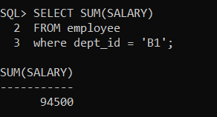

**FUNCTION**: can calculate the total salary for the particular department.

**QUERY 2:**

SELECT COUNT(employee_id)

FROM employee

WHERE dept_id = 'B1';

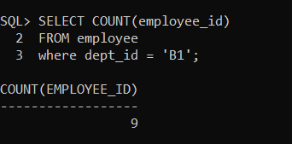

**FUNCTION**: can count whether how many employees allocate in the department.

**QUERY 3:**

ALTER TABLE employee

ADD NICKNAME VARCHAR2(20);

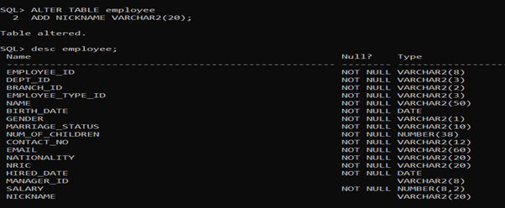

**FUNCTION**: allow CEO/manager to alter the table like add new column.

**QUERY 4:**

UPDATE employee

SET NICKNAME = 'EDDIE'

WHERE employee_id = 'A10000';

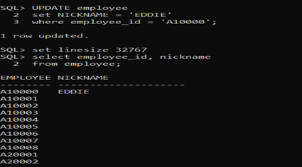

**FUNCTION**: It allow employee to UPDATE the existing records in the table.

**QUERY 5:**

SELECT employee_id, name

FROM employee

WHERE marriage_status = 'SINGLE';

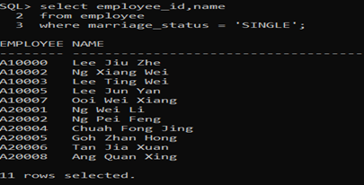

**FUNCTION**: allow the employee to search for something with condition, for example search for the name of employees that are single.

**QUERY 6:**

SELECT employee_id, name, salary

FROM employee

WHERE salary BETWEEN 4500 AND 8000;

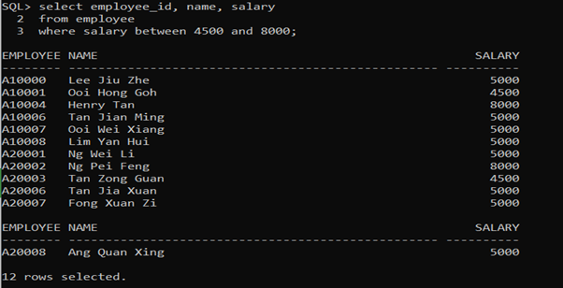

**FUNCTION**: allow employee to search for the employee within the range of the salary for bonus calculation or other reason.

**QUERY 7:**

DESC employee;

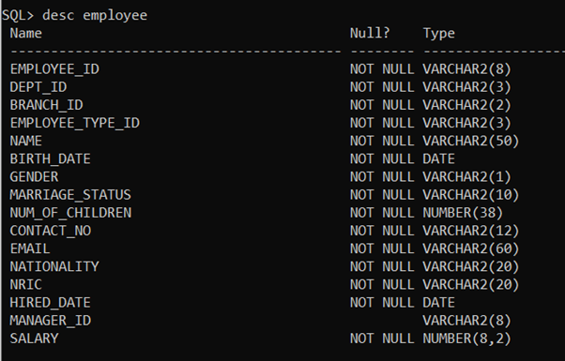

**FUNCTION**: describe the employee table.

**QUERY 8:**

SELECT name

FROM employee

WHERE name LIKE 'T%';

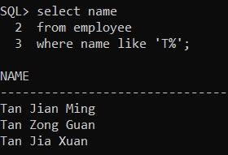

**FUNCTION**: to select some employee with name start from the specific alphabet.

**QUERY 9:**

SELECT employee_id, name, employee_type_id

FROM employee

WHERE employee_type_id IN (1, 2, 5)

ORDER BY employee_type_id;

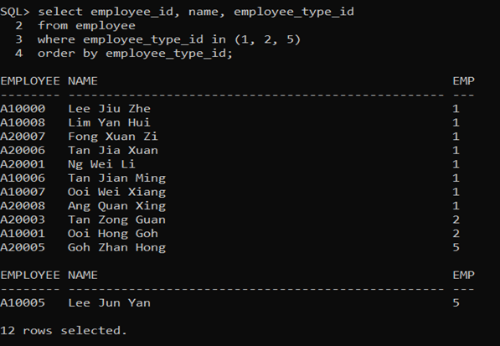

**FUNCTION**: select the employee with employee type id in multiple specific values.

**QUERY 10:**

SELECT MAX(salary)

FROM employee

WHERE dept_id = 'B1';

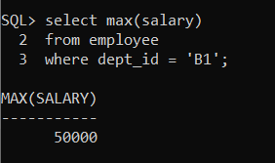

**FUNCTION**: find out which employee with the highest salary.

**7.2 STORED PROCEDURES**

**Procedure 1:**

CREATE OR REPLACE PROCEDURE add_employee

(employee_id in VARCHAR2,

dept_id in VARCHAR2,

branch_id in VARCHAR2,

employee_type_id in VARCHAR2,

name in VARCHAR2,

birth_date in DATE,

gENDer in VARCHAR2,

employee_id in VARCHAR2,

employee_id in VARCHAR,

marriage_status in VARCHAR2, num_of_children in NUMBER, contact_no in VARCHAR2, email in VARCHAR2, nationality in VARCHAR2, nric in VARCHAR2, hired_date in DATE, manager_id in VARCHAR2, salary in NUMBER)

IS BEGIN

INSERT INTO employee VALUES

(employee_id, dept_id, branch_id, employee_type_id, name, birth_date, gender, employee_id ,employee_id, marriage_status, num_of_children, contact_no, email, nationality, nric, hired_date, manager_id, salary);

COMMIT;

END;

/

EXECUTE add_employee('A30001 ', 'B1', 'B', '5', 'OWEN' ,date '2001-03-06', 'M', 'SINGLE', '0', '013-5112657', 'owen01@gmail.com', 'Malaysia', '010306-70-5623',date '2020-04-01', 'A10002', '2000');

**EXPLANATION:** This procedure is created for the user to add new recruit employees

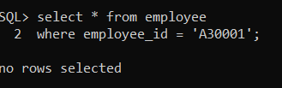

Figure 1: SHOW THE TABLE BEFORE ADDED NEW EMPLOYEE

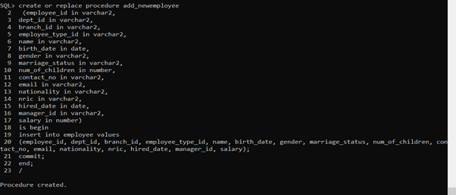

Figure 2: CREATE PROCEDURE add_employee



Figure3: PERFORMING EXECUTION TO ADD NEW EMPLOYEE

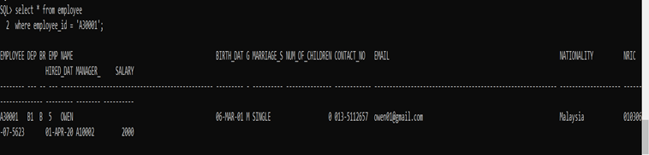

Figure 3: AFTER ADDED NEW EMPLOYEE

**Procedure 2:**

CREATE OR REPLACE PROCEDURE update_employee

(sel_employee_id in VARCHAR2,

new_name in VARCHAR2)

IS BEGIN

UPDATE employee

SET name = new_name

WHERE employee_id = sel_employee_id;

COMMIT;

END;

/

EXECUTE update_employee(‘A30001’, ‘OXWALD’);

WHERE employee_id = ‘A30001’;

**EXPLANATION:** This procedure is created with the purpose of allowing the users to update the employee’s data for example name.



Figure 1: SHOW THE TABLE BEFORE UPDATE THE EMPLOYEE

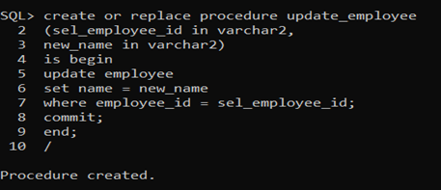

Figure 2: CREATE THE PROCEDURE UPDATE_EMPLOYEE

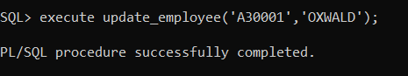

Figure 3: SHOW THE EXECUTE OF THE PROCEDURE SUCCESSFUL

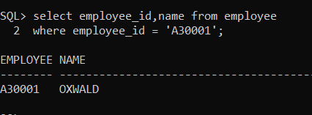

Figure 4: SHOW THE SELECTED EMPLOYEE AFTER CHANGES

**Procedure 3:**

CREATE OR REPLACE PROCEDURE delete_employee

(del_employee_id in VARCHAR2)

IS BEGIN

DELETE FROM employee

WHERE employee_id = del_employee_id;

COMMIT;

END;

/

EXECUTE delete_employee(‘A30001’);

**EXPLANATION:** This procedure is created for the users to delete any employee that is no longer working for that company.



Figure 1: SHOW THE EMPLOYEE BEFORE DELETE

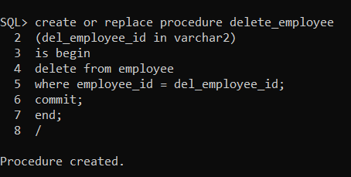

Figure 2: CREATING THE PROCEDURE DELETE_EMPLOYEE

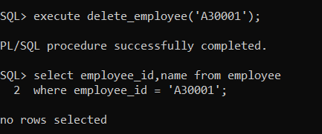

Figure 3: SHOW THE PROCEDURE TO DELETE SUCCESSFUL

**Procedure 4:**

CREATE OR REPLACE PROCEDURE update_salary

(s_employee_id in VARCHAR2,

New_salary in NUMBER)

IS BEGIN

UPDATE employee

SET salary = new_salary

WHERE employee_id = s_employee_id;

COMMIT;

END;

/

EXECUTE update_salary(‘A10000’, ‘8000’);

**EXPLANATION:** This procedure is created for the users to update the employee's salary.

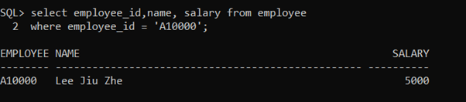

Figure 1 SHOW THE TABLE BEFORE UPDATE THE SALARY

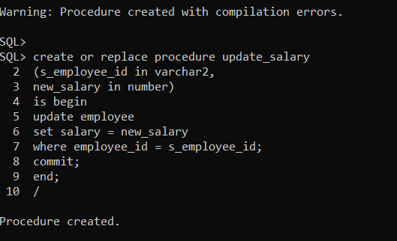

Figure 2 SHOW THE STEP FOR CREATING PROCEDURE UPDATE_SALARY

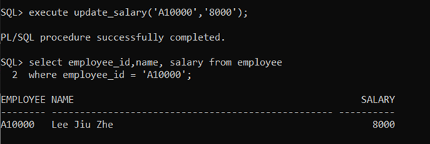

Figure 3 AFTER THE SALARY HAD BEEN UPDATED

**Procedure 5:**

CREATE OR REPLACE PROCEDURE update_employee_type

(semployee_id in VARCHAR2,

newemployee_type in VARCHAR2)

IS BEGIN

UPDATE employee

SET employee_type_id = newemployee_type;

WHERE employee_id = semployee_id;

COMMIT;

END;

/

EXECUTE update_salary(‘A10000’, ‘8000’);

**EXPLANATION:** This procedure is created for the purpose of update the employee’s role

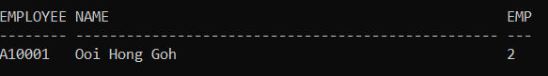

Figure 1 BEFORE UPDATE THE EMPLOYEE'S ROLE

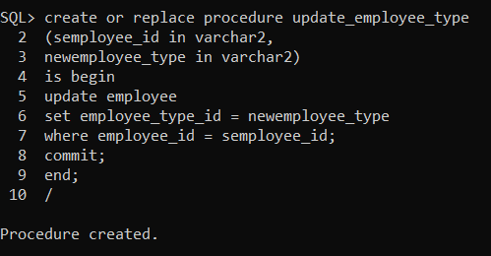

Figure 2 CREATING THE PROCEDURE TO UPDATE THE EMPLOYEE ROLE

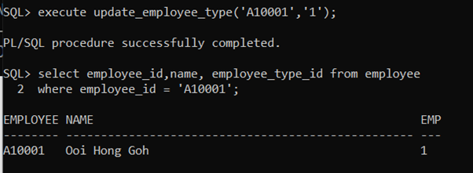

Figure 3 SHOW THE SUCCESS OF UPDATING THE ROLE OF EMPLOYEE

**7.3 FUNCTION**

**Function 1:**

CREATE OR REPLACE FUNCTION totalnum

(d_id VARCHAR2)

RETURN VARCHAR2

IS

Totale VARCHAR2(50);

BEGIN

SELECT COUNT(employee_id) INTO totale FROM employee

WHERE dept_id = d_id;

RETURN(totale);

END;

/

DECLARE

BEGIN

DBMS_OUTPUT.PUT_LINE(‘The total employee in the department is ‘|| totalnum(‘&department_id’) ||’.’);

END;

/

**EXPLANATION:** This function is created to calculate the total number of the employee in a specific department.

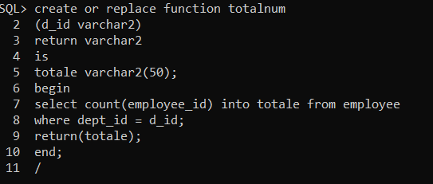

Figure 1 STEP OF CREATING THE FUNCTION TO CALCULATE TOTAL EMPLOYEE

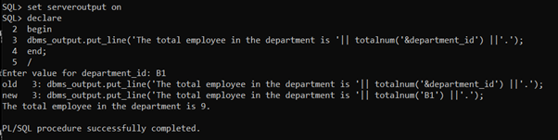

Figure 2 DISPLAY THE TOTAL EMPLOYEE IN DEPARTMENT B1

**Function 2:**

CREATE OR REPLACE FUNCTION total_income

(d_id in VARCHAR2)

RETURN VARCHAR2

IS

totalin NUMBER;

BEGIN

SELECT SUM(salary) INTO totalin FROM employee

WHERE dept_id = d_id;

RETURN(totalin);

END;

/

DECLARE

BEGIN

DBMS_OUTPUT.PUT_LINE(‘The total income of this department is ‘|| total_income(‘&department_id’) ||’.’);

END;

/

**EXPLANATION:** This function is created to calculate the total income of a selected department.

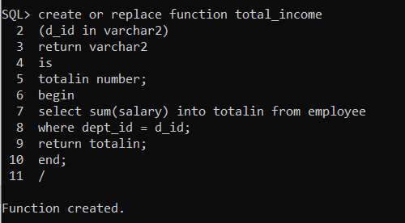

Figure 1 CREATING THE FUNCTION TO CALCULATE THE TOTAL INCOME

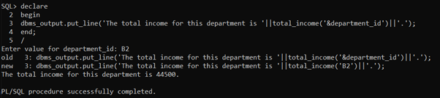

Figure 2 DISPLAY THE OUTPUT(TOTAL INCOME) OF THE DEPARTMENT B2

**Function 3:**

CREATE OR REPLACE FUNCTION marriagestatus1

(d_id in VARCHAR2)

RETURN VARCHAR2

IS

single VARCHAR2(50);

married VARCHAR2(50);

result VARCHAR2(100);

BEGIN

SELECT COUNT(DISTINCT(employee_id)) INTO single FROM employee

WHERE dept_id = d_id AND marriage_status = ‘SINGLE’;

SELECT COUNT(DISTINCT(employee_id)) INTO married FROM employee

WHERE dept_id = d_id AND marriage_status = ‘MARRIED’;

result:=‘There are ‘||single||’ of employees are still single and ‘||married||’ employees are married’;

RETURN(result);

END;

/

DECLARE

BEGIN

DBMS_OUTPUT.PUT_LINE(marriagestatus1(‘&department_id’));

END;

/

**EXPLANATION:** This function is created to find out the exact marriage status of all the employees in a department.

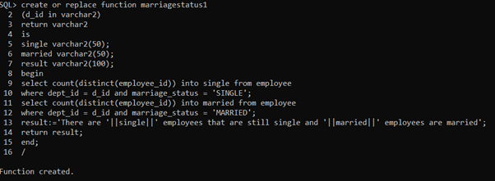

Figure 1 CREATING THE FUNCTION TO CHECK FOR THE MARRIAGE STATUS OF EMPLOYEES IN A DEPARTMENT

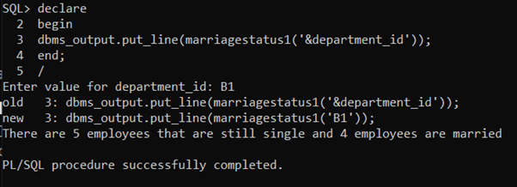

Figure 5 SHOW THE EXACT MARRIAGE STATUS OF EMPLOYEE IN THE DEPARTMENT B1

**Function 4:**

CREATE OR REPLACE FUNCTION manager

(b_id in VARCHAR2)

RETURN VARCHAR2

IS

totalmanager VARCHAR2(30);

BEGIN

SELECT COUNT(distinct(employee_type_id)) INTO totalmanager FROM employee

WHERE branch_id = b_id AND employee_type_id = ‘3’;

RETURN totalmanager;

END;

/

DECLARE

BEGIN

DBMS_OUTPUT.PUT_LINE(‘The total income of this department is ‘|| total_income(‘&department_id’) ||’.’);

END;

/

**EXPLANATION:** This function is created to find out how many managers the department had.

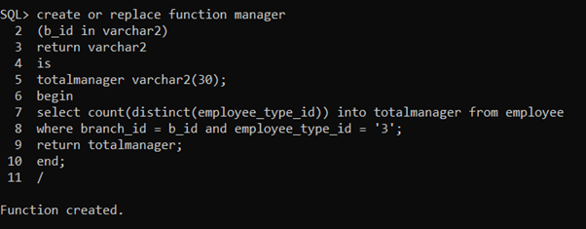

Figure 1 CREATING THE FUNCTION TO FIND THE AMOUNT OF MANAGER IN A DEPARTMENT

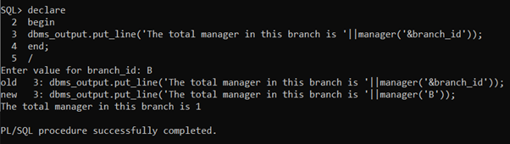

Figure 2 DISPLAY THE EXACT AMOUNT OF EMPLOYEE IN DEPARTMENT B

**Function 5:**

CREATE OR REPLACE FUNCTION subordinate1

(emp_id in VARCHAR2)

RETURN VARCHAR2

IS

mng_name VARCHAR2(30);

mng_id VARCHAR2(20);

result VARCHAR2(100);

BEGIN

SELECT COUNT(employee_id) INTO totalsub FROM employee

WHERE manager_id = emp_id;

SELECT name INTO mng_name from employee

WHERE employee_id = emp_id;

Result:=‘Employee ‘||mng_name||’ with ‘||mng_id||’ has a total of ‘||totalsub||’ subORdinates.’;

RETURN result;

END;

/

DECLARE

BEGIN

DBMS_OUTPUT.PUT_LINE(subordinate1(‘&manager_id’));

END;

/

**EXPLANATION:** This function is created to find out subordinates a manager has.

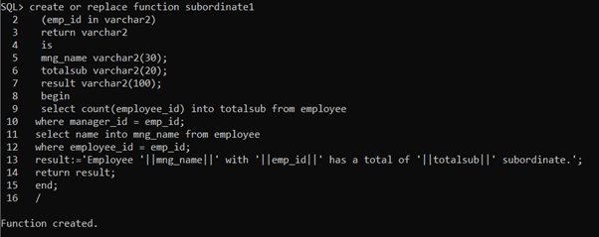

Figure 1 CREATING THE FUNCTION TO FIND OUT THE NUMBER OF SUBORDINATE OF A EMPLOYEE

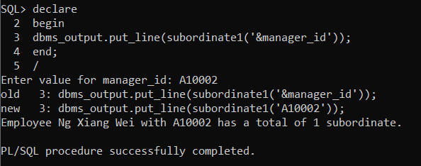

Figure 6 DISPLAY THE EXACT AMOUNT OF SUBORDINATE OF EMPLOYEE A10002

**8.0 Individual Assessment (Tan Zhi Xuan 17ACB03376)**

**8.1 QUERIES**

**Query 1:**

SELECT emp_leave_id,l.employee_id AS "EMPLOYEE_ID", t.leave_id,

t.leave_type as "Leave type", total_leave_taken as "Days Taken", leave_remain

FROM leave_balance l join leave_type t

ON l.leave_id=t.leave_id

WHERE l.leave_id='&leave_id';

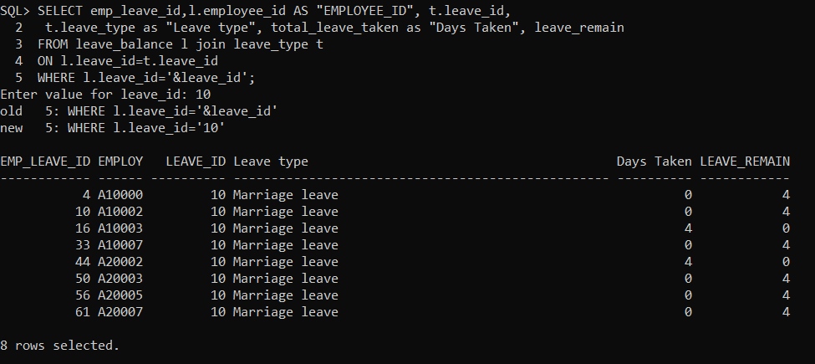

This query enables users to be able to get the selected leave id and display all the selected same type of leave from the leave balance table.

**Query 2:**

CREATE OR REPLACE VIEW employee_working_years AS

SELECT employee_id, name, role, trunc((sysdate-hired_date)/365.25) AS "Total Years Worked"

FROM employee E, employee_type T

where E.employee_type_id=T.employee_type_id

ORDER BY "Total Years Worked" DESC

WITH READ only;

SELECT * FROM employee_working_years;

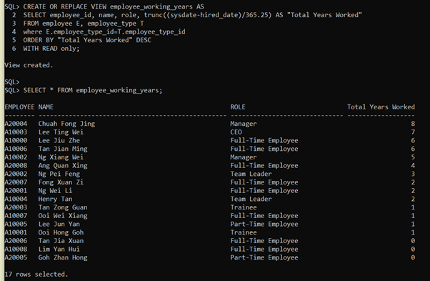

This query enables users to be able to calculate how many years the employee works.

**Query 3:**

CREATE OR REPLACE VIEW only_approved AS

SELECT e.employee_id, e.name, r.application_status as status, t.leave_type, r.leave_date, r.days_request

FROM employee e, leave_report r, leave_type t

Where ((e.employee_id=r.employee_id) AND (r.leave_id=t.leave_id))

AND(application_status='APPROVED');

SELECT * FROM only_approved;



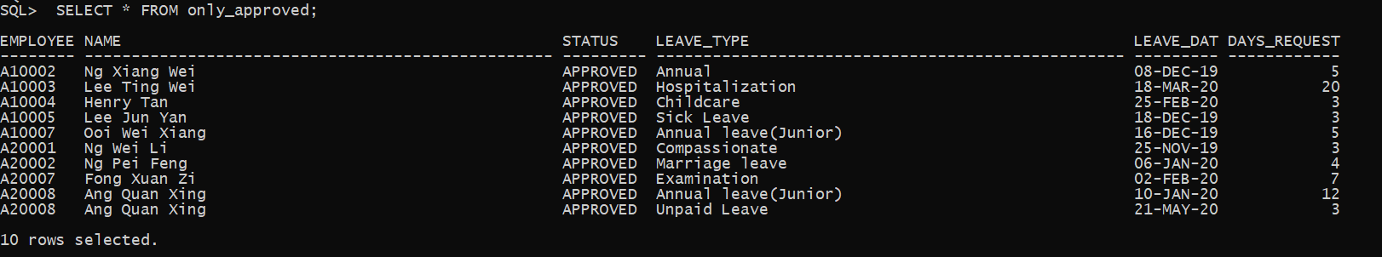

This query has been created a view to display all those with approved status in the future or passed.

**Query 4:**

select employee_id, name, employee_type_id as "Role type",

CASE gender

when 'M' THEN 'Male'

when 'F' THEN 'Female'

ELSE 'N/A'

END as "Gender"

from employee

WHERE (gender='F' AND employee_type_id NOT IN ('5', '2'));

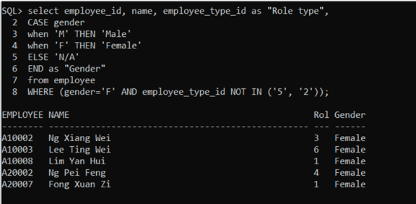

This query changes the gender to become more meaningful in terms of words. Hence this select is to display all the female employees except trainee and part time employees. So that only full-time female employees can apply for maternity leave.

**Query 5:**

SELECT l.employee_id,e.name,l.emp_leave_id

FROM employee e join leave_balance l

ON e.employee_id=l.employee_id

WHERE name='&name';

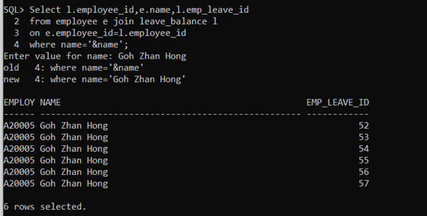

This query enables the user to input the employee name to retrieve all the leave balance id from the selected employee.

**Query 6:**

SELECT e.employee_id, e.name, b.leave_id AS "Leave Type", b.total_leave_taken AS "Days taken", b.leave_remain AS "DAYS Left"

FROM employee e join leave_balance b

ON e.employee_id=b.employee_id

WHERE leave_remain<=0 AND leave_id IN (1,2);

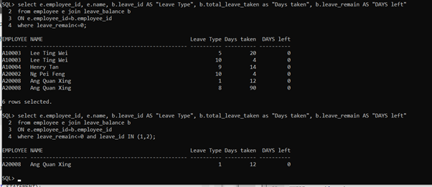

This query is to display the employee who has used up all their annual leave this year.

**Query 7:**

SELECT leave_id,

SUM (total_leave_taken) as "SUM Days Taken",

Trunc(AVG(total_leave_taken)) as "Average Days Taken"

FROM leave_balance

GROUP BY leave_id;

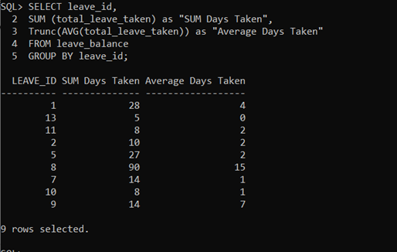

This query is to calculate the sum and average days taken for each leave_id.

**Query 8:**

CREATE OR REPLACE VIEW Formal_Emp AS

SELECT * FROM employee

WHERE employee_type_id NOT IN ('5', '2')

ORDER BY employee_id DESC;

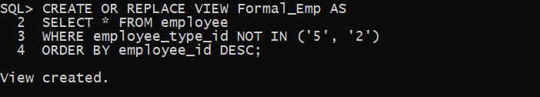

SELECT * FROM Formal_Emp;

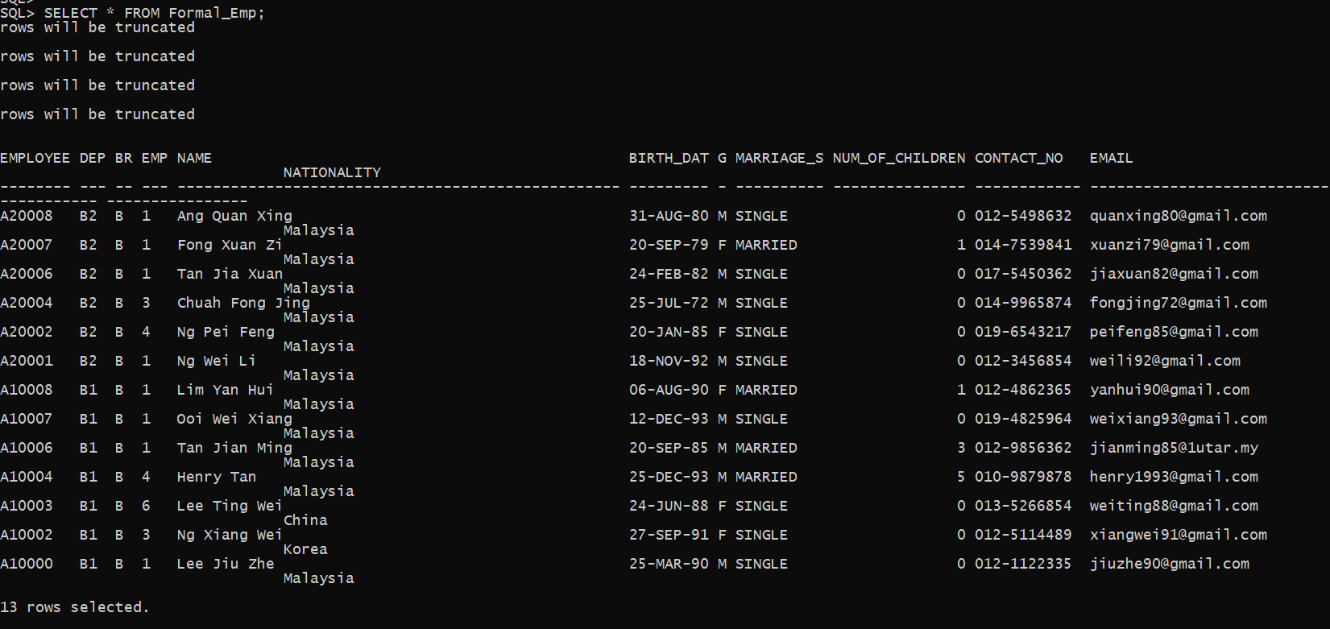

This view is used to enable the user to provide most of the leave to all the formal employees except part-time employees and trainees. Due to part-time employees and trainees can only apply unpaid leave which is listed in business rules.

**Query 9:**

SELECT e.employee_id,e.name, e.salary*12 AS "Annual Salary", t.role

FROM employee e JOIN employee_type t

ON e.employee_type_id = t.employee_type_id

ORDER BY “Annual Salary” DESC;

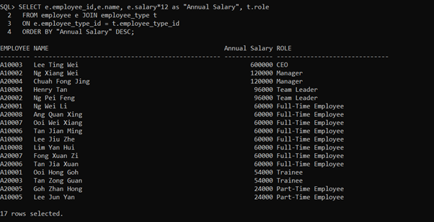

This query enables users to calculate the annual salary for each of the employees and together with the role position in the whole company.

**Query 10:**

CREATE OR REPLACE VIEW employee_manager_view AS

SELECT e.employee_id AS "EMPLOYEE ID",e.name AS "EMPLOYEE NAME", e.employee_type_id,

m.employee_id AS "MANAGER ID", m.name AS "MANAGER NAME"

FROM employee e, employee m

WHERE m.employee_id=e.manager_id;

SELECT * FROM employee_manager_view;

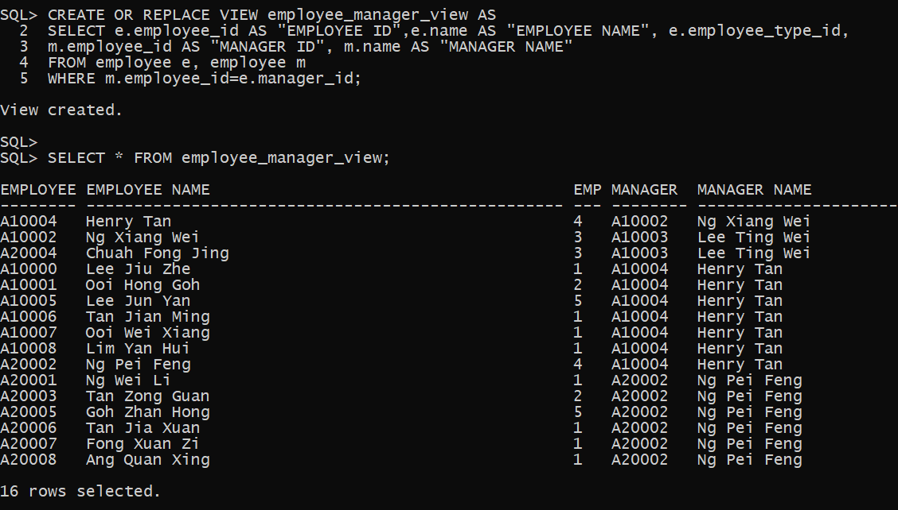

This query enables users to view or find all the employees and listed them with their manager. So that in future this allows the manager to change their subordinate leave status.

**8.2 STORED PROCEDURE**

**Procedure 1:**

CREATE OR REPLACE PROCEDURE add_branch

(

new_branch_id in VARCHAR,

new_br_name in VARCHAR,

new_email in VARCHAR,

new_est_date in DATE,

new_address in VARCHAR,

new_phone_no in VARCHAR

)

IS

BEGIN

INSERT INTO branch VALUES ( new_branch_id,

new_br_name ,

new_email,

new_est_date,

new_address,

new_phone_no);

COMMIT;

END;

/

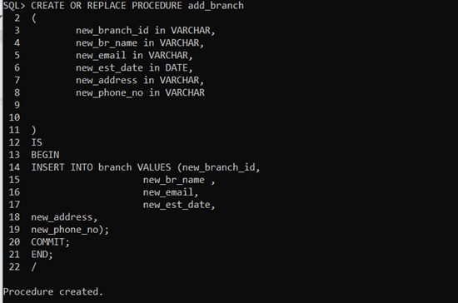

Function: Allow user to add a new branch record.

Before the user add_branch procedure.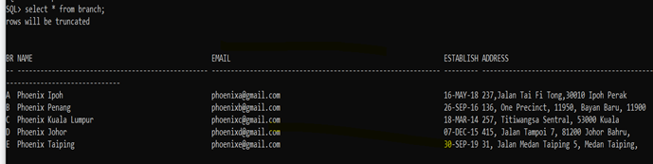

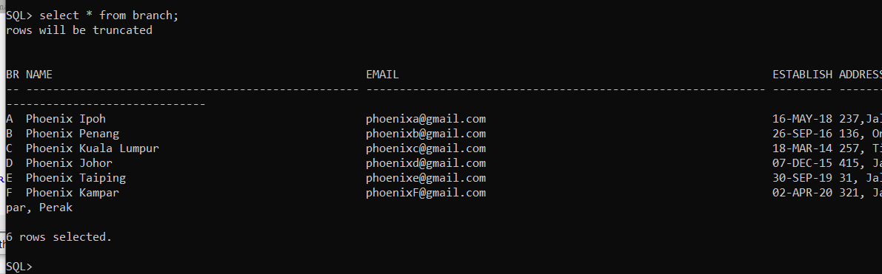

A new record with branch_id with ‘F’ is inserted after add the add_branch procedure.

EXEC add_branch('F', 'Phoenix Kampar', 'phoenixF@gmail.com', '2-APR-20', '321, Jalan Kampar 10, Taman Kampar, 31700 Kampar, Perak', '03-1235678');

**Procedure 2:**

CREATE OR REPLACE PROCEDURE add_leave_balance

(

new_emp_leave_id in NUMBER,

new_employee_id in VARCHAR2,

new_leave_id in NUMBER,

new_total_leave_taken in NUMBER,

new_leave_remain in NUMBER

)

IS

BEGIN

INSERT INTO leave_balance VALUES (new_emp_leave_id,

new_employee_id ,

new_leave_id,

new_total_leave_taken,

new_leave_remain);

COMMIT;

END;

/

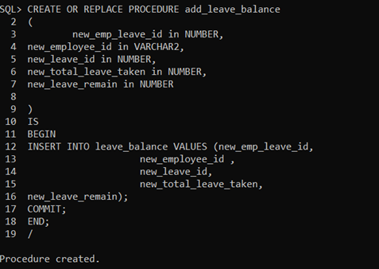

Function: Allow user to add a new branch record.

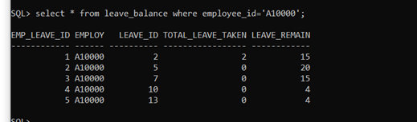

Before the user use add_leave_balance procedure.

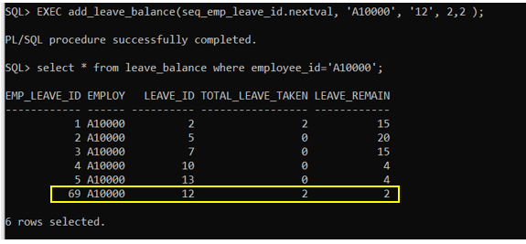

EXEC add_leave_balance(seq_emp_leave_id.nextval, 'A10000', '12', 2,2 );

A new record with emp_leave_id with ‘69’ is inserted after adding the add_leave_balance procedure.

**Procedure 3:**

CREATE OR REPLACE PROCEDURE update_leave_balance

(

selected_emp_leave_id IN NUMBER,

new_leave_id IN NUMBER,

new_total_leave_taken IN NUMBER

)

IS

BEGIN

UPDATE leave_balance

SET leave_id = new_leave_id ,

total_leave_taken = total_leave_taken + new_total_leave_taken,

leave_remain= leave_remain - new_total_leave_taken

WHERE emp_leave_id = selected_emp_leave_id;

COMMIT;

END;

/

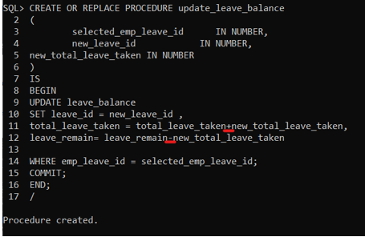

Function: Allow the user to modify the leave balance record

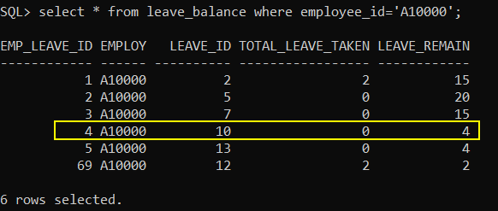

Before executing the update_leave_balance procedure.

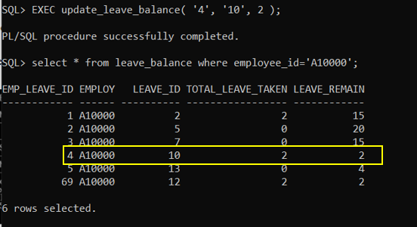

After executing the procedure, the value of leave taken and remaining changed at emp_leave_id with ‘4’.

When user enters the leave_taken value 2, it will automatically minus leave_remain 2.

EXEC update_leave_balance( '4', '10', 2 );

EXEC update_leave_balance( emp_leave_id, leave_id, total_leave_taken);

**Procedure 4:**

CREATE OR REPLACE PROCEDURE delete_leave_balance

(

selected_emp_leave_id IN VARCHAR

)

IS

BEGIN

DELETE FROM leave_balance WHERE emp_leave_id = selected_emp_leave_id;

COMMIT;

END;

/

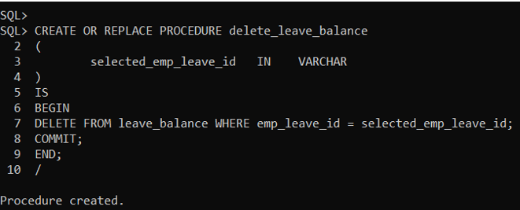

Function: To allow the user to delete the unused leave_balance record faster.

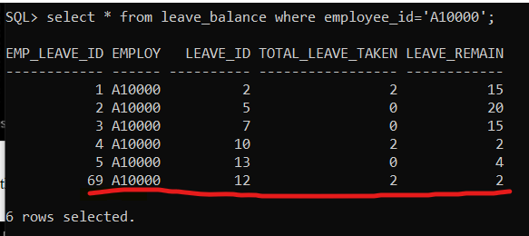

Before executing the delete_leave_balance procedure.

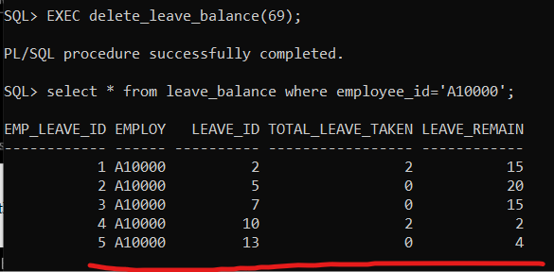

After executing the procedure, the emp_leave_id with 69 has been removed.

EXEC delete_leave_balance(69);

EXEC delete_leave_balance(emp_leave_id);

**Procedure 5:**

CREATE OR REPLACE PROCEDURE deleteLeaveType

(selected_leave_id IN NUMBER)

IS

BEGIN

DELETE FROM leave_balance where leave_id =selected_leave_id AND exists( select * from leave_balance where leave_id =selected_leave_id);

DELETE FROM leave_report where leave_id =selected_leave_id AND exists( select * from leave_report where leave_id =selected_leave_id);

DELETE FROM leave_type WHERE leave_id = selected_leave_id;

COMMIT;

END;

/

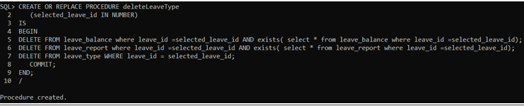

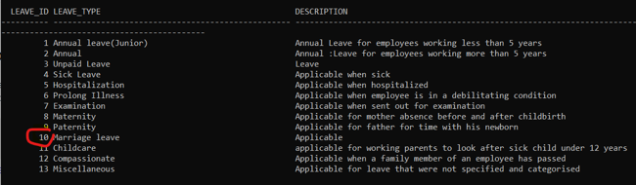

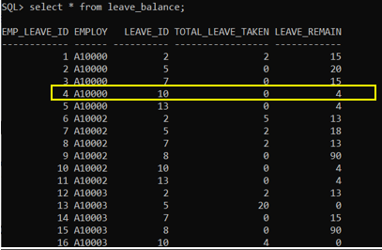

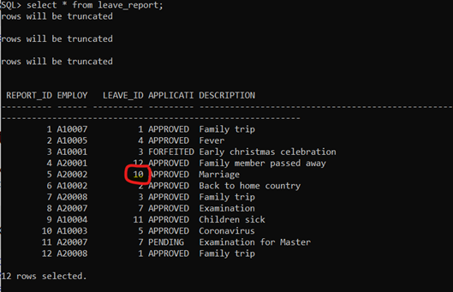

Before executing the deleteLeaveType procedure still contains leave_id 10.

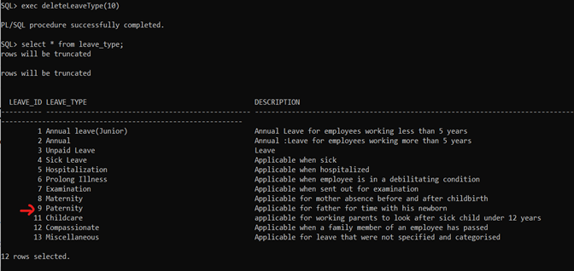

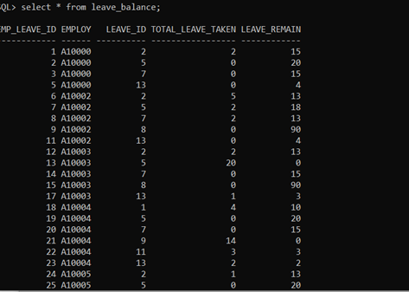

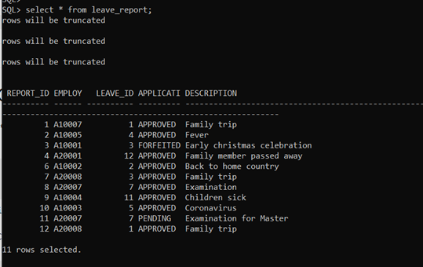

After executing the procedure, the leave_id in 10 has been removed in three tables which are leave_type, leave_report and leave_blalance.

exec deleteLeaveType(10)

**8.3 FUNCTIONS**

**Function 1:**

Create function:

CREATE OR REPLACE FUNCTION cal_numLeave(selected_employee_id IN varchar2)

RETURN NUMBER

IS

total NUMBER;

BEGIN

SELECT SUM(total_leave_taken) INTO total FROM leave_balance

where employee_id=selected_employee_id;

RETURN total;

END;

/

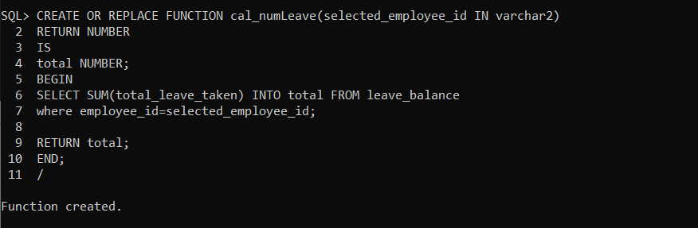

**Run function:**

DECLARE

total_record NUMBER;

employee_id varchar2(50);

BEGIN

total_record := cal_numLeave(&employee_id);

DBMS_OUTPUT.PUT_LINE('Total number of leave applied for employee_id : ' || total_record);

END;

/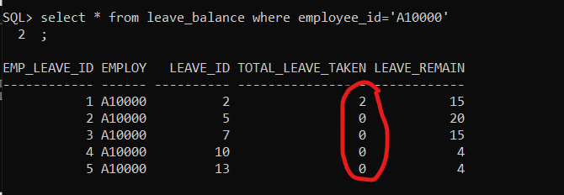

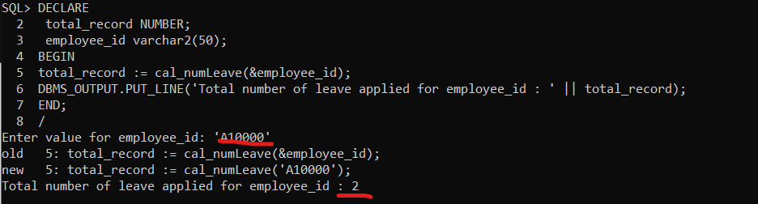**Explanation:**

From both the above diagrams we know that the function is performed successfully and displays the output of the total leave applied for employee A10000 as 2. This function is used to calculate the total number of leaves applied for the selected employee with the input of employee_id as parameter.

**Function 2:**

Create function:

CREATE OR REPLACE FUNCTION GenderPercentage

RETURN VARCHAR2

IS

percentageM NUMBER(5,2);

percentageF NUMBER(5,2);

Total NUMBER;

Male NUMBER;

Female NUMBER;

BEGIN

SELECT COUNT(*) into Total from employee;

SELECT COUNT(*) into Male from employee

where gender='M';

SELECT COUNT(*) into Female from employee

where gender='F';

percentageM:=Male/Total * 100;

percentageF:=100-percentageM;

RETURN('Total employee: '||Total||'

Total Male and Female employee: '||Male||', '||Female||'

Total Male and Female employee percentage: '||percentageM||', '||percentageF||' ');

END;

/

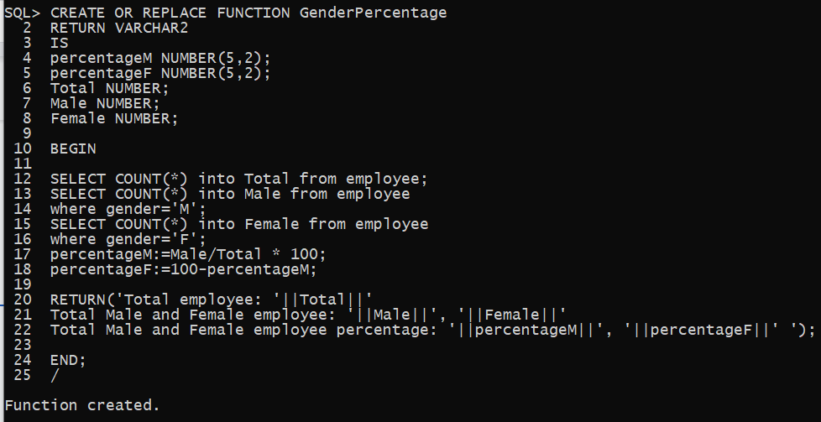

Run function:

DECLARE

BEGIN

DBMS_OUTPUT.PUT_LINE(GenderPercentage);

END;

/

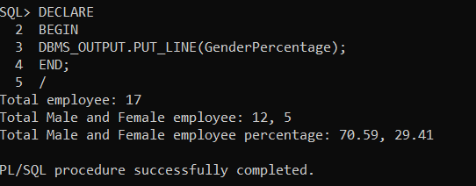

Explanation:

This function is to display and calculate the number of total employees, number of male and female employees and the percentages of both gender in the YY company. This result seems like an IT company.

**Function 3:**

Create function

CREATE OR REPLACE FUNCTION calcLeave(s_leave_id IN NUMBER)

RETURN VARCHAR2

IS

percentageT NUMBER(5,2);

percentageR NUMBER(5,2);

taken NUMBER;

remain NUMBER;

BEGIN

SELECT SUM(total_leave_taken) INTO taken FROM leave_balance

WHERE leave_id=s_leave_id;

SELECT SUM(leave_remain) INTO remain FROM leave_balance

WHERE leave_id=s_leave_id;

percentageT:=taken/(taken+remain) * 100;

percentageR:=100-percentageT;

RETURN('

leave_id: '||(s_leave_id)||'

Total days taken and days remain leave: '||taken||' days, '||remain||' days

Total taken and remain days percentage: '||percentageT||'%, '||percentageR||'%');

END;

/

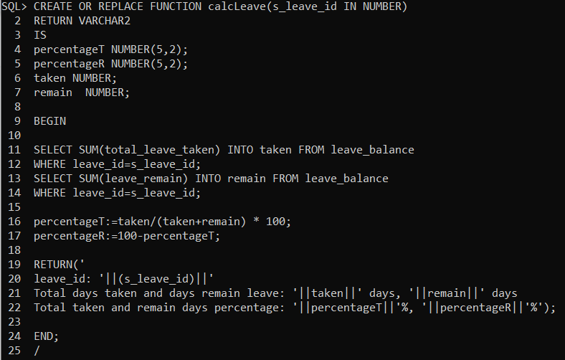

Run function:

DECLARE

BEGIN

DBMS_OUTPUT.PUT_LINE(calcLeave(&s_leave_id));

END;

/

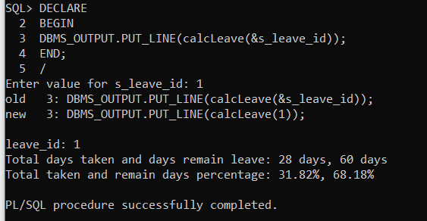

Explanation:

This function is used to display and calculate the number of leave days taken and days remaining. The users just need to input the leave id then they can get the percentages of days taken and remaining.

**Function 4:**

Create Function:

CREATE OR REPLACE FUNCTION ChildLeave(s_emp_id IN varchar)

RETURN VARCHAR2

IS

numC NUMBER;

maxDays NUMBER;

givenDays NUMBER;

BEGIN

SELECT num_of_children INTO numC FROM employee

WHERE employee_id=s_emp_id;

SELECT leave_days_per_year INTO maxDays FROM leave_type

WHERE leave_id=11;

givenDays:= numC*2;

IF (givenDays>maxDays) THEN

givenDays:=maxDays;

END IF;

RETURN('

Selected Employee ID: '||(s_emp_id)||'

Number of Children: '||(numC)||'

Max Days Capped: '||(maxDays)||' days

Days Given: '||(givenDays)||' days');

END;

/

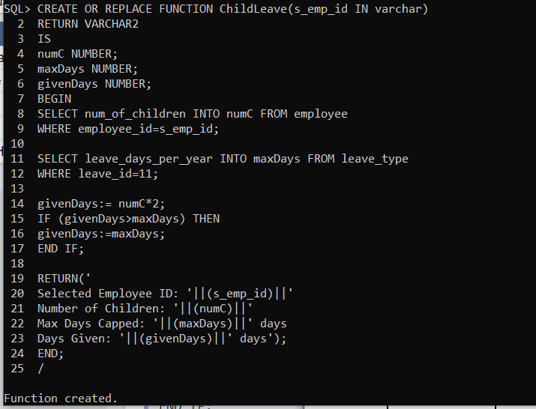

**Run Function:**

DECLARE

BEGIN

DBMS_OUTPUT.PUT_LINE(ChildLeave(&s_emp_id));

END;

/

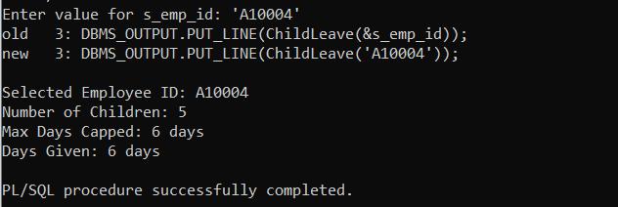

**Explanation:**

If one day, the government comes out with a new policy for all the companies, the requirement is each employee will be given 2 days of childcare leave for each child's age which is below 12 years old. But the maximum capped is 6 days, for example if an employee has 2 children then he/she will get 4 days of childcare leave per year.

This function mainly calculates the days given to each employee who has at least one child.

**Function 5:**

**Create function:**

CREATE OR REPLACE FUNCTION EmptyAnnual

RETURN VARCHAR2

IS

finish NUMBER;

BEGIN

SELECT COUNT(*) INTO finish FROM leave_balance

WHERE (leave_remain<=0 AND leave_id IN (1,2));

RETURN('Number of employees who finish their annual leave: '||finish||' ');

END;

/

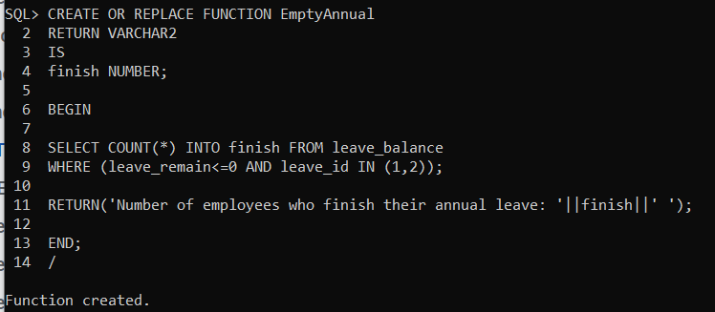

**Run function:**

DECLARE

BEGIN

DBMS_OUTPUT.PUT_LINE(EmptyAnnual);

END;

/

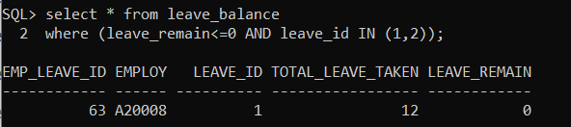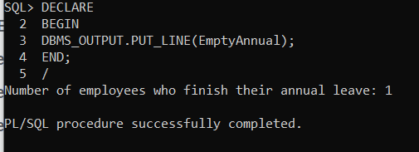

**Explanation:**

This function is used to display the employee who finished their annual leave, then the employee has to take unpaid leave if he or she still wants to take more leave.

**9.0 Individual Assessment (Leong Hong Xin 17ACB04530)**

**9.1 QUERIES**

**Query 1:**

CREATE OR REPLACE VIEW branch_view AS

SELECT branch_id||'-'||branch_name AS "Branches (ID-Name)",

establish_date,

ROUND((SYSDATE - establish_date)/365.25, 1) AS "UPTIME(YEARS)"

FROM branch;

SELECT * FROM branch_view;

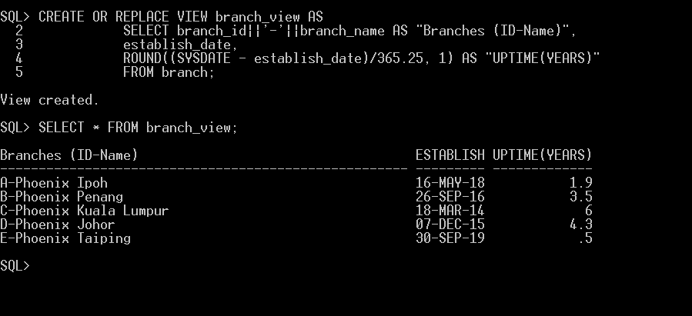

Function: Allow users to use branch_view to view all the branches and their established dates in years.

**Query 2:**

SELECT branch.branch_id||'-'||branch.branch_name AS "Branch (ID-Name)",

COUNT(*) AS "Employees_in_branch"

FROM employee

FULL JOIN branch ON employee.branch_id = branch.branch_id

WHERE branch.branch_id = 'B'

GROUP BY branch.branch_id||'-'||branch.branch_name;

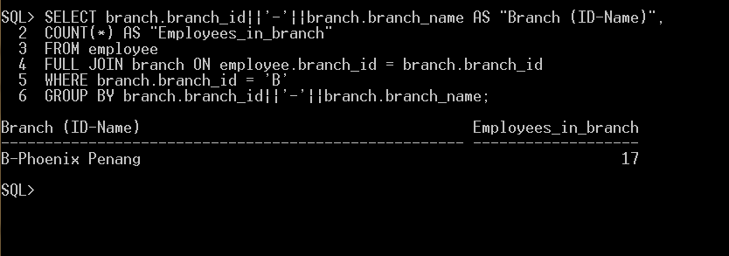

Function: Allow users to check the number of employees within a branch using its ID.

**Query 3:**

UPDATE branch

SET phone_no = '05324358968',

email = 'phoenixc@pnix.com'

WHERE branch_id = 'C';

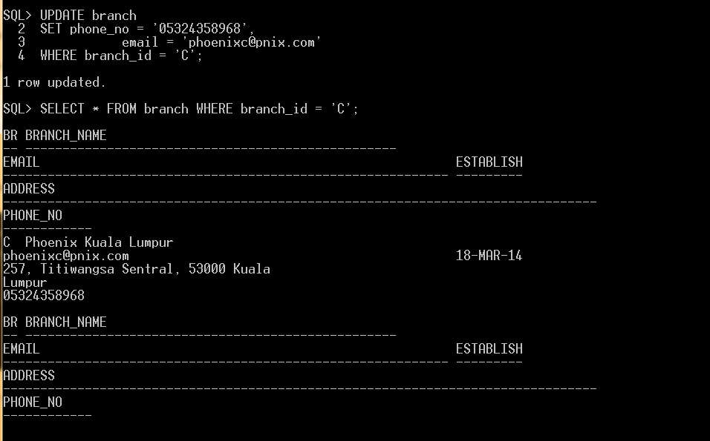

Function: Allows users to update branch contact details such as phone number and email.

**Query 4:**

CREATE OR REPLACE VIEW branch_details AS

SELECT branch_id||'-'||branch_name AS "Branches (ID-Name)",

email||'['|| phone_no || ']'AS "Contact Details(email[phone]) ",

address

FROM branch;

SELECT * FROM branch_details;

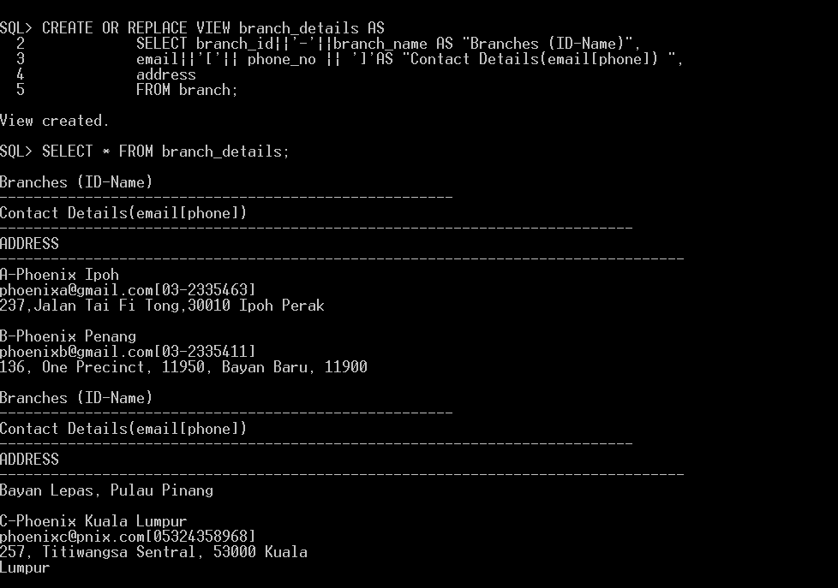

Function: Allow users to view all the branches’ contact details.

**Query 5:**

SELECT COUNT(*)

FROM ((employee

FULL JOIN leave_report ON employee.employee_id = leave_report.employee_id )

FULL JOIN branch ON employee.branch_id = branch.branch_id)

WHERE leave_report.application_status = 'APPROVED' AND branch.branch_id = 'B';

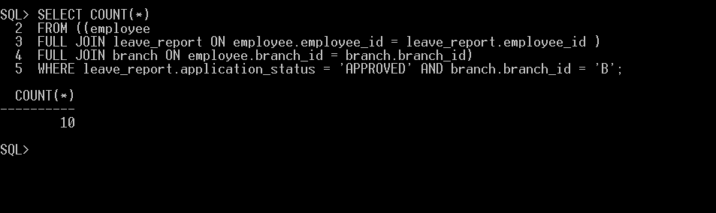

Function: Allow users to check the employees which are on leave in a given branch.

**Query 6:**

CREATE OR REPLACE VIEW dept_in_branch AS

SELECT branch.branch_name,

branch.branch_id AS "ID",

department.dept_name AS "Department"

FROM department

FULL JOIN branch ON department.branch_id = branch.branch_id

ORDER BY branch.branch_id;

SELECT * FROM dept_in_branch;

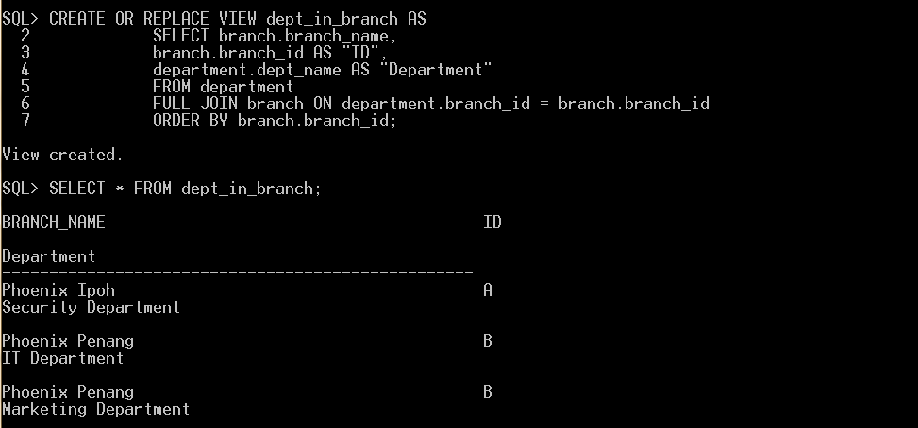

Function: Allow users to view the branches of the company, their associative branch ID and the departments under each branch.

**Query 7:**

SELECT department.dept_id||'-'||department.dept_name AS "Department (ID-Name)",

employee.name AS "Name"

FROM employee

FULL JOIN department ON employee.dept_id = department.dept_id

ORDER BY department.dept_id;

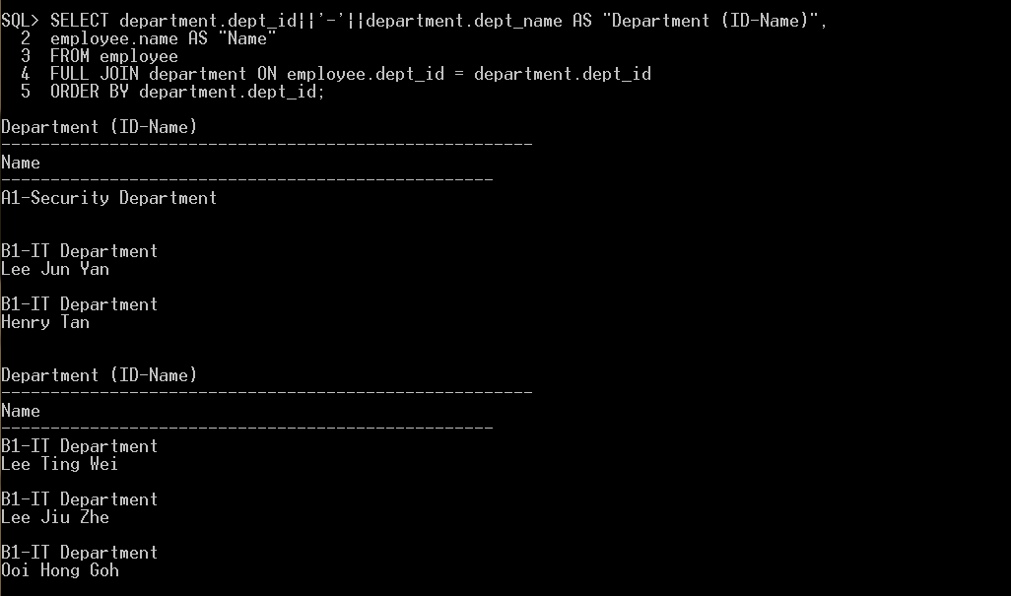

Function: Allow users to view all employees’ names and the department they are under.

**Query 8:**

SELECT department.dept_name AS "Department",

COUNT(*) AS "Employee on Leave"

FROM ((employee

FULL JOIN leave_report ON employee.employee_id = leave_report.employee_id )

FULL JOIN department ON employee.dept_id = department.dept_id)

WHERE leave_report.application_status = 'APPROVED' AND department.dept_id = 'B1'

GROUP BY department.dept_name;

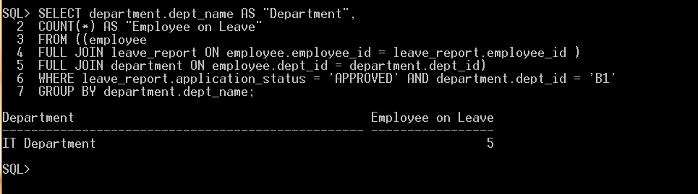

Function: Allow users to check the employees which are on leave in a given department.

**Query 9:**

SELECT branch.branch_id||'-'||branch.branch_name AS "Branches (ID-Name)",

branch.email||'['|| branch.phone_no || ']'AS "Contact Details(email[phone]) ",

branch.address

FROM department

FULL JOIN branch ON department.branch_id = branch.branch_id

WHERE department.dept_id = 'A1';

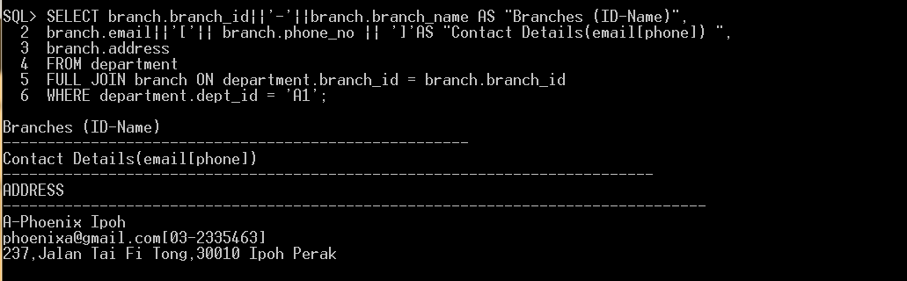

Function: Allow users to obtain contact details of their branch using their department ID.

**Query 10:**

SELECT employee.name AS "Name",

department.dept_name AS "Department",

leave_report.application_status AS "Leave Status"

FROM ((employee

FULL JOIN leave_report ON employee.employee_id = leave_report.employee_id )

FULL JOIN department ON employee.dept_id = department.dept_id)

WHERE leave_report.application_status = 'APPROVED' AND department.dept_id = 'B1';

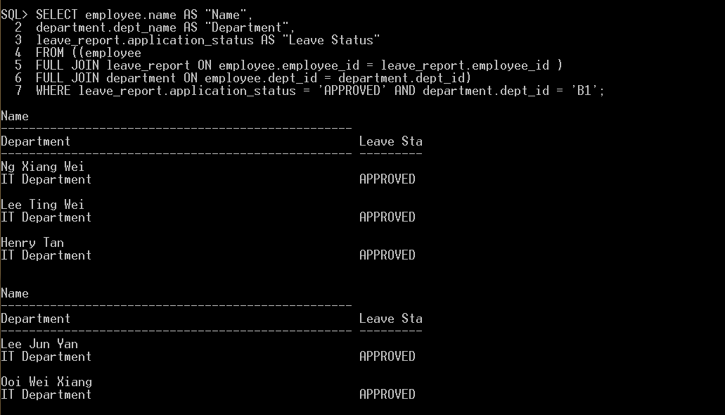

Function: Allow users to view employees that are on leave under a given department.

**9.2 STORED PROCEDURES:**

**Procedure 1:**

CREATE OR REPLACE PROCEDURE add_dept

(

new_dept_id in VARCHAR,

new_branch_id in VARCHAR,

new_dept_name in VARCHAR,

new_dept_total_emp in INT

)

IS

BEGIN

INSERT INTO department VALUES (new_dept_id,

new_branch_id,

new_dept_name,

new_dept_total_emp);

COMMIT;

END;

/

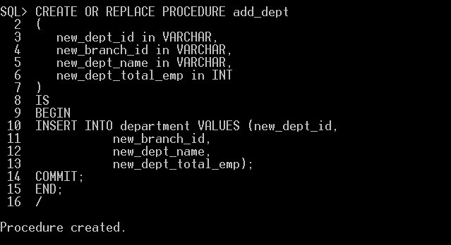Function: Allows user to add a new department record.

Before the use of add_dept procedure.

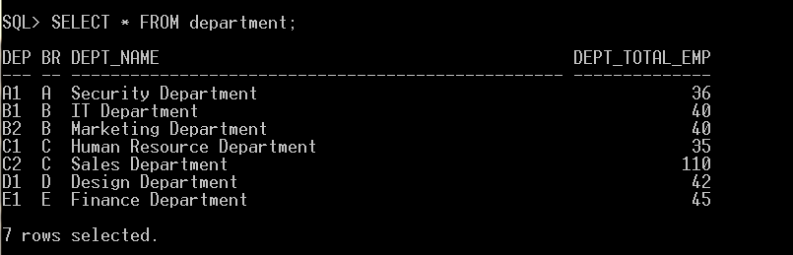After add_dept procedure.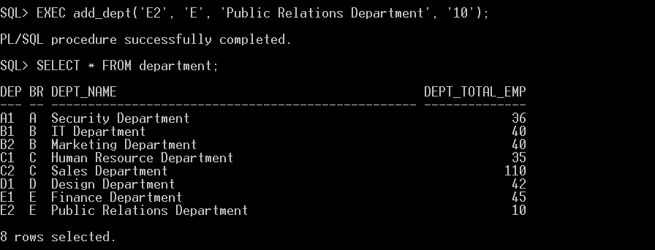

**Procedure 2:**

CREATE OR REPLACE PROCEDURE update_branch_contacts

(

selected_branch_id IN VARCHAR,

new_email IN VARCHAR,

new_address IN VARCHAR,

new_phone_no IN VARCHAR

)

IS

BEGIN

UPDATE branch

SET email = new_email,

address = new_address,

phone_no = new_phone_no

WHERE branch_id = selected_branch_id;

COMMIT;

END;

/

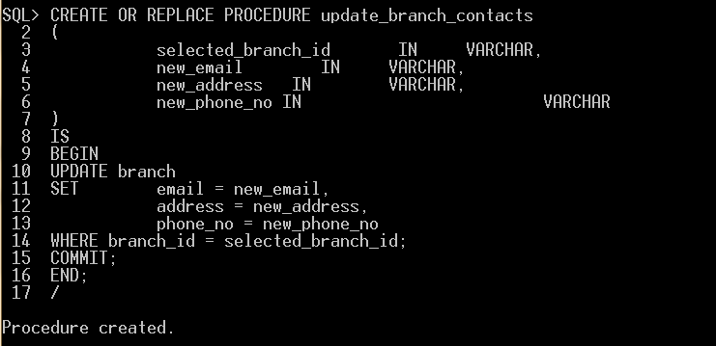

Function: Allows user to update contact details of a branch.

Before the use of update_branch_contacts procedure.

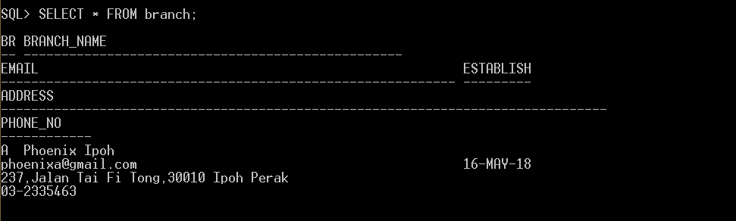

After update_branch_contacts procedure.

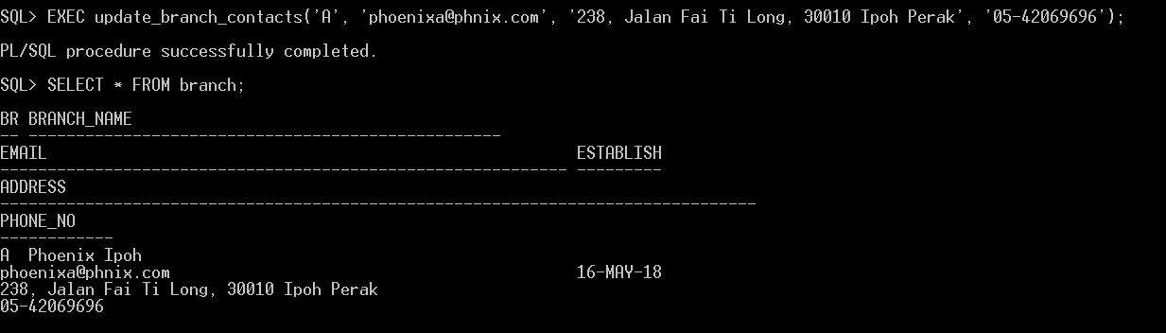

**Procedure 3:**

CREATE OR REPLACE PROCEDURE dept_change_branch

(

selected_dept_id IN VARCHAR,

new_branch_id IN VARCHAR,

new_dept_id IN VARCHAR

)

IS

BEGIN

UPDATE department

SET branch_id = new_branch_id,

dept_id = new_dept_id

WHERE dept_id = selected_dept_id;

COMMIT;

END;

/

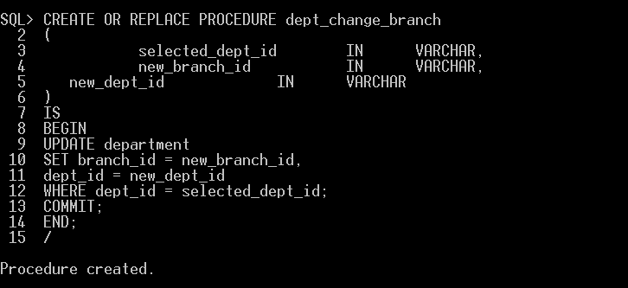

Function: Allows user to change the branch of a department when needed.

Before the use of dept_change_branch.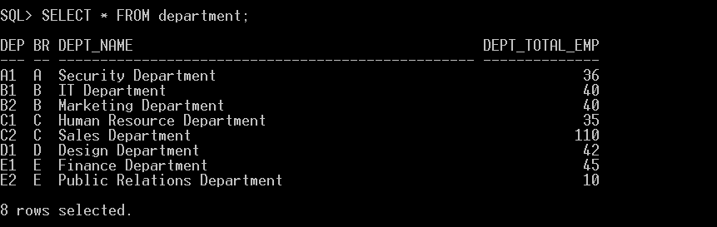

After the use of dept_change_branch.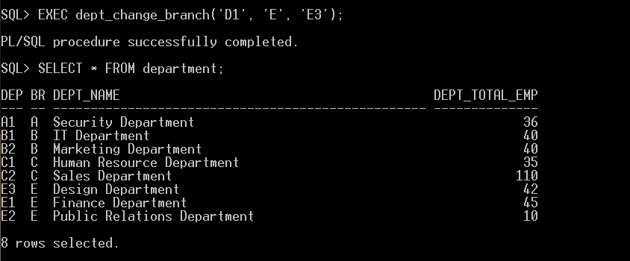

**Procedure 4:**

CREATE OR REPLACE PROCEDURE delete_dept

(

selected_dept_id IN VARCHAR

)

IS

BEGIN

DELETE FROM department WHERE dept_id = selected_dept_id;

COMMIT;

END;

/

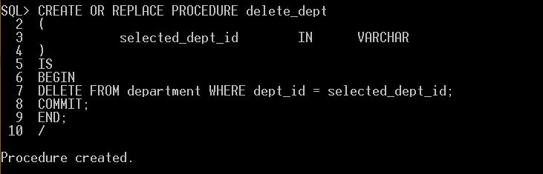

Function: Allows user to delete a department when it is to be dissolved.

Before the use of delete_dept.

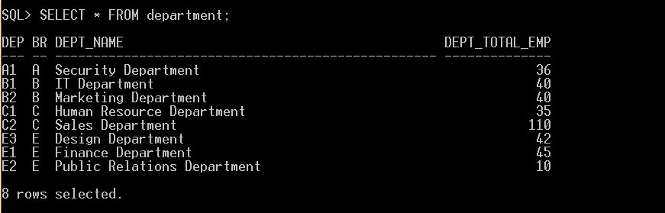

After the use of delete_dept.

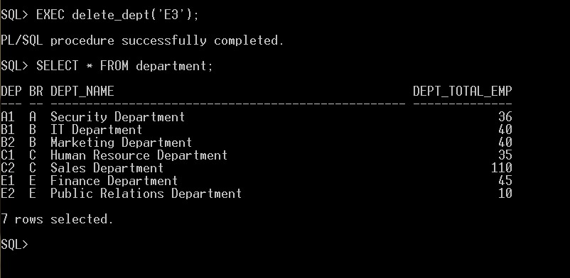

**Procedure 5:**

CREATE OR REPLACE PROCEDURE delete_branch

(

selected_branch_id IN VARCHAR

)

IS

dept_count NUMBER;

BEGIN

SELECT COUNT(*) INTO dept_count from department WHERE branch_id = selected_branch_id;

IF (dept_count != 0)

THEN

DBMS_OUTPUT.PUT_LINE('Branch not empty.');

COMMIT;

ELSE

DELETE FROM branch WHERE branch_id = selected_branch_id;

COMMIT;

END IF;

END;

/

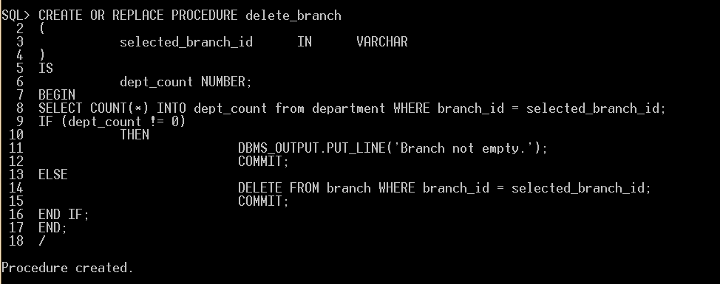

Function: Allows user to delete a branch entry when all departments under it has been dissolved.

Before the use of delete_branch.

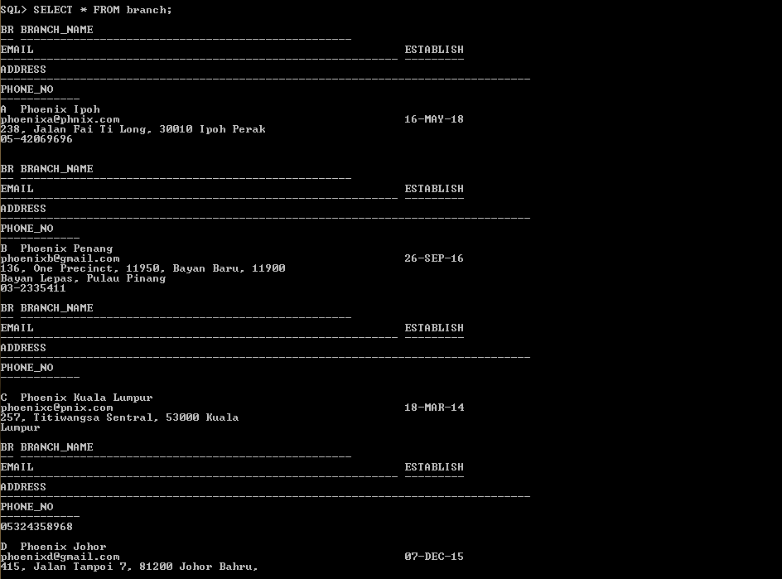

If delete_branch is used on a non-empty branch. (e.g. Branch A)

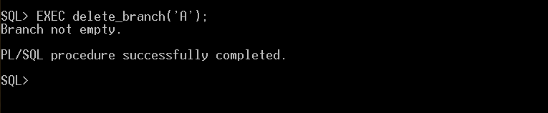

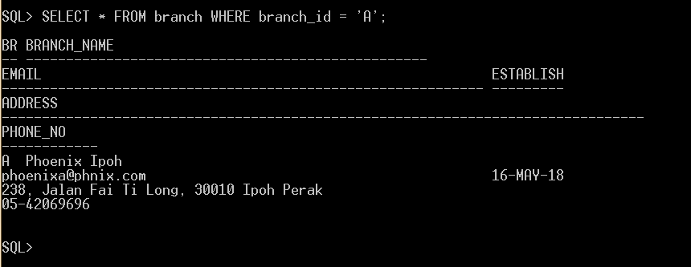

If delete_branch is used on an empty branch. (e.g. Branch D).

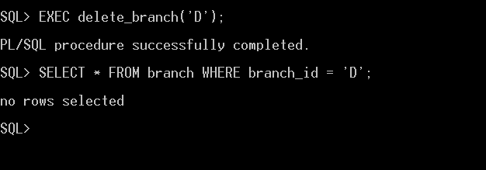

**9.3 FUNCTIONS:**

**Function 1:**

CREATE OR REPLACE FUNCTION branch_emp_no

(given_branch_id IN VARCHAR)

RETURN NUMBER

IS

current_emp_no NUMBER;

BEGIN

SELECT COUNT(*) INTO current_emp_no FROM employee WHERE branch_id = given_branch_id;

RETURN current_emp_no;

END branch_emp_no;

/

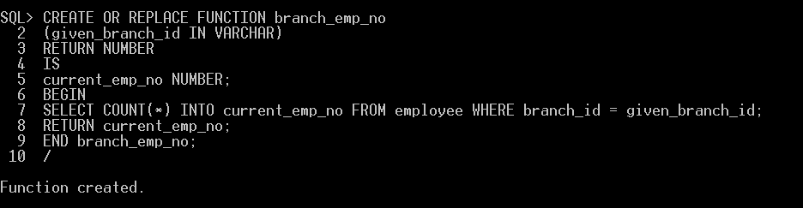

Function: Takes branch_id as a parameter and returns the number of employees under the current branch.

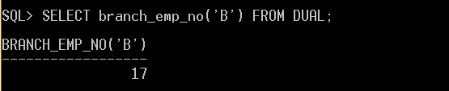

**Function 2:**

CREATE OR REPLACE FUNCTION branch_emp_on_leave

(given_branch_id IN VARCHAR)

RETURN NUMBER

IS

leave_emp_no NUMBER;

BEGIN

SELECT COUNT(*) INTO leave_emp_no

FROM ((employee

FULL JOIN leave_report ON employee.employee_id = leave_report.employee_id )

FULL JOIN branch ON employee.branch_id = branch.branch_id)

WHERE leave_report.application_status = 'APPROVED' AND branch.branch_id = given_branch_id;

RETURN leave_emp_no;

END branch_emp_on_leave;

/

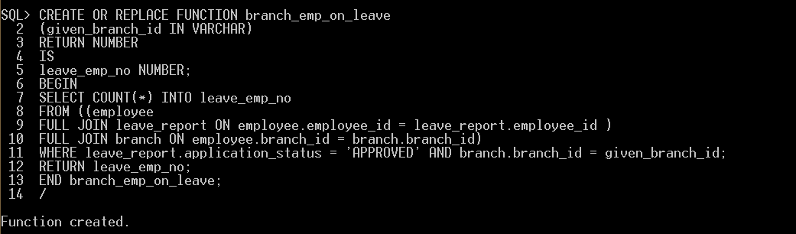

Function: Takes branch_id as a parameter and returns the number of employees under the current branch that is currently on leave.

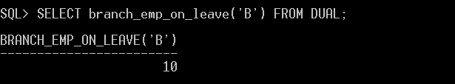

**Function 3:**

CREATE OR REPLACE FUNCTION available_emp_in_branch

(given_branch_id IN VARCHAR)

RETURN NUMBER

IS

leave_emp_no NUMBER;

available_emp_no NUMBER;

BEGIN

leave_emp_no := branch_emp_on_leave(given_branch_id);

available_emp_no := branch_emp_no(given_branch_id) - leave_emp_no;

RETURN available_emp_no;

END available_emp_in_branch;

/

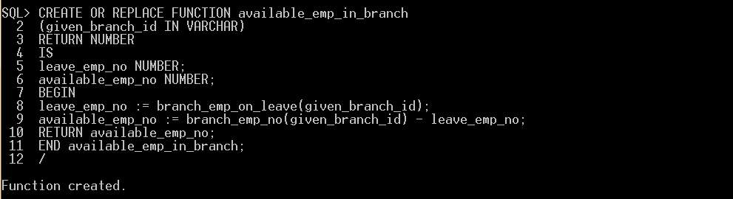

Function: Takes branch_id as a parameter and returns the number of employees that are available and not on leave of the current branch.

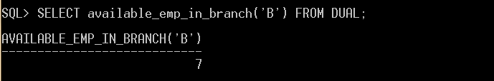

**Function 4:**

CREATE OR REPLACE FUNCTION dept_emp_on_leave

(given_dept_id IN VARCHAR)

RETURN NUMBER

IS

leave_emp_no NUMBER;

BEGIN

SELECT COUNT(*) INTO leave_emp_no

FROM ((employee

FULL JOIN leave_report ON employee.employee_id = leave_report.employee_id )

FULL JOIN department ON employee.dept_id = department.dept_id)

WHERE leave_report.application_status = 'APPROVED' AND department.dept_id = given_dept_id;

RETURN leave_emp_no;

END dept_emp_on_leave;

/

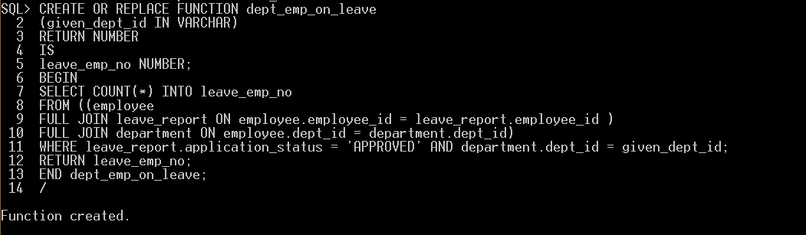

Function: Takes dept_id as a parameter and returns the number of employees on leave under the current department.

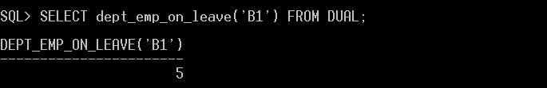

**Function 5:**

CREATE OR REPLACE FUNCTION available_emp_in_dept

(given_dept_id IN VARCHAR)

RETURN NUMBER

IS

current_emp_no NUMBER;

leave_emp_no NUMBER;

available_emp_no NUMBER;

BEGIN

SELECT COUNT(*) INTO current_emp_no FROM employee WHERE dept_id = given_dept_id;

leave_emp_no := dept_emp_on_leave(given_dept_id);

available_emp_no := current_emp_no - leave_emp_no;

RETURN available_emp_no;

END available_emp_in_dept;

/

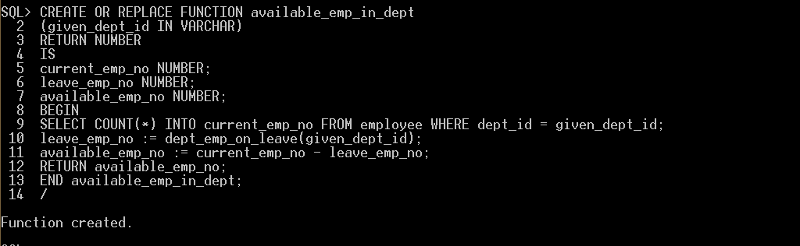

Function: Takes dept_id as a parameter and returns the number of employees that are available and not on leave under the current department.

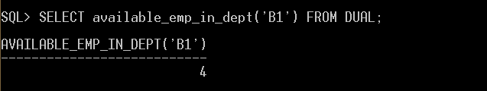

**10.0 Individual Assessment (Lam Kean Chin 17ACB05143)**

**10.1 QUERIES**

**Query 1:**

CREATE OR REPLACE VIEW employee_type_number AS

SELECT employee_type_id , COUNT(*) AS "number_of_employee"

FROM employee

GROUP BY employee_type_id

ORDER BY employee_type_id;

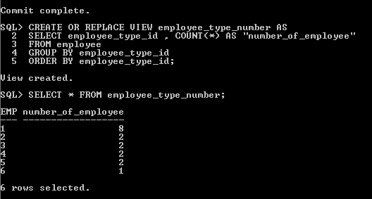

Function: Allow the user to view the number of types of employee existing in the company.

**Query 2:**

SELECT count(*) AS number_of_employee_type

FROM employee_type;

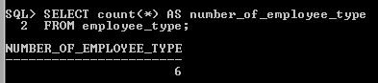

Function: Allow the user to view how many types of employee exist in the company.

**Query 3:**

ALTER TABLE employee_type

ADD role_level NUMBER(1);

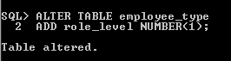

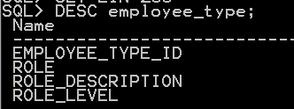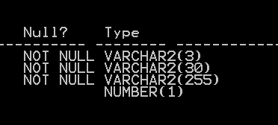

Function: Query that let the user insert a new column that stores the role level of the employee type.

**Query 4:**

UPDATE employee_type

SET role_level = 7

WHERE employee_type_id = 1;

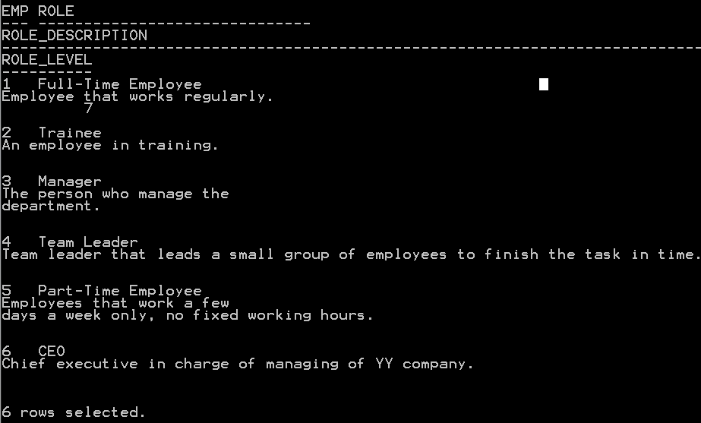

Function: Query that is used to insert the role level of the employee type.

**Query 5:**

CREATE OR REPLACE VIEW leave_type_number AS

SELECT leave_id , COUNT(*) AS "leave_type_taken"

FROM leave_report

GROUP BY leave_id

ORDER BY leave_id;

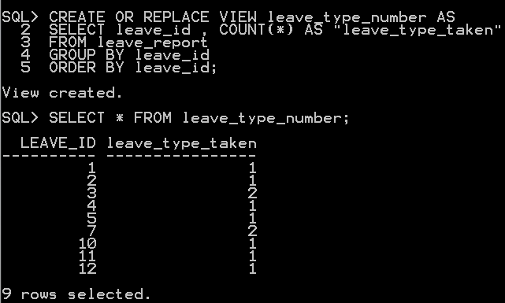

Function: The user will be able to view the number of leave types taken in the company to know what kind of leave is take most often.

**Query 6:**

SELECT count(*) as number_of_leave_type

FROM leave_type;

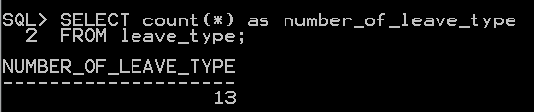

Function: The user will be able to view how many leave types exist in the company.

**Query 7:**

ALTER TABLE leave_type

ADD emergency VARCHAR2(9) DEFAULT 'undefined' ;

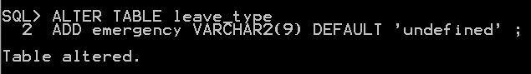

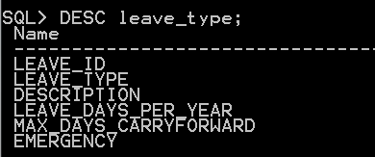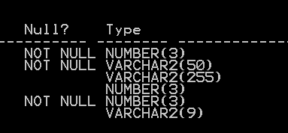

Function: Query that lets the user to insert a new column into emergency with a default value undefined in it.

**Query 8:**

UPDATE leave_type

SET emergency = 'Yes'

WHERE leave_id=1;

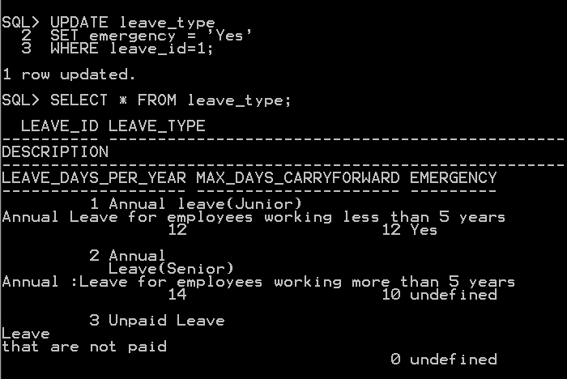

Function: Query that lets the user to update the emergency status in the leave_type table.

**Query 9:**

SELECT leave_id , COUNT(*) AS "leave_balance_type_exist"

FROM leave_balance

GROUP BY leave_id

ORDER BY leave_id;

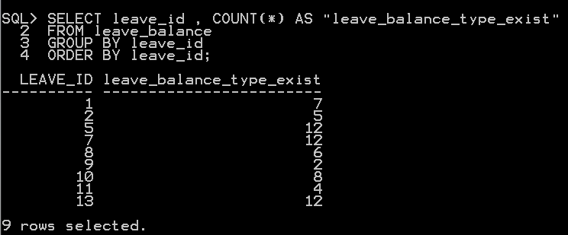

Function: The user will be able to view how many leave types with balance are used in this company.

**Query 10:**

SELECT employee_id, name,

SUBSTR(name, 1, instr(name, ' ') - 1) AS first_name,

SUBSTR (name, instr(name, ' ') + 1) AS last_name

FROM employee;

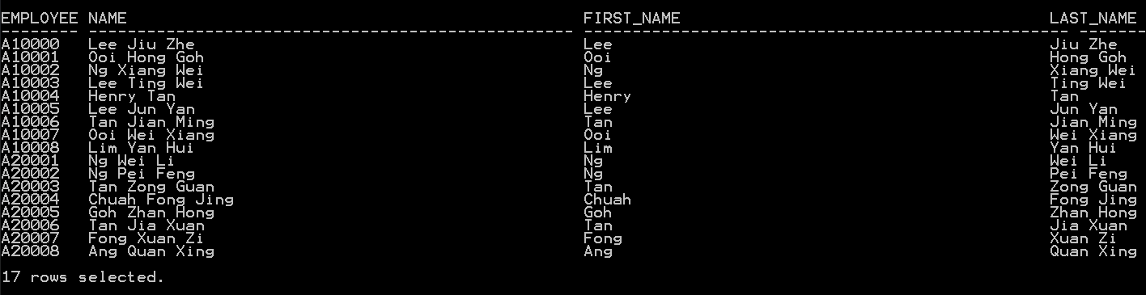

Function: The user will be able to separate the employee name with first name and last name.

**10.2 STORED PROCEDURES:**

**Procedure 1:**

CREATE OR REPLACE PROCEDURE add_employee_type

(

new_employee_type_id in VARCHAR,

new_role in VARCHAR,

new_role_description in VARCHAR)

IS BEGIN

INSERT INTO employee_type VALUES

(

new_employee_type_id,

new_role,

new_role_description);

COMMIT;

END;

/

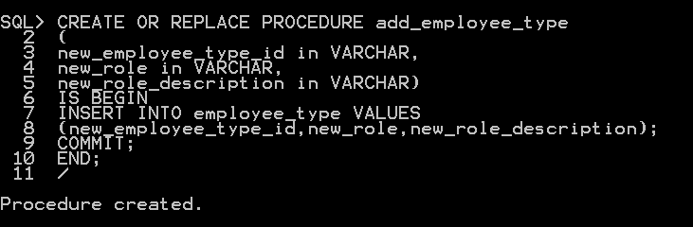

Function: Allow the user to insert new employee type into employee type table using procedure.

Before using the add_employee_type procedure.

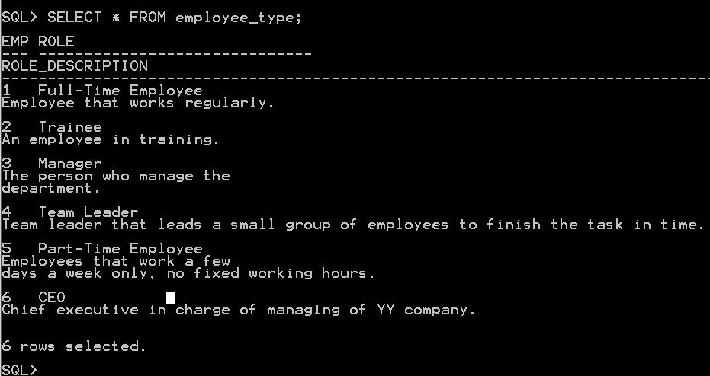

After the add_employee_type procedure.

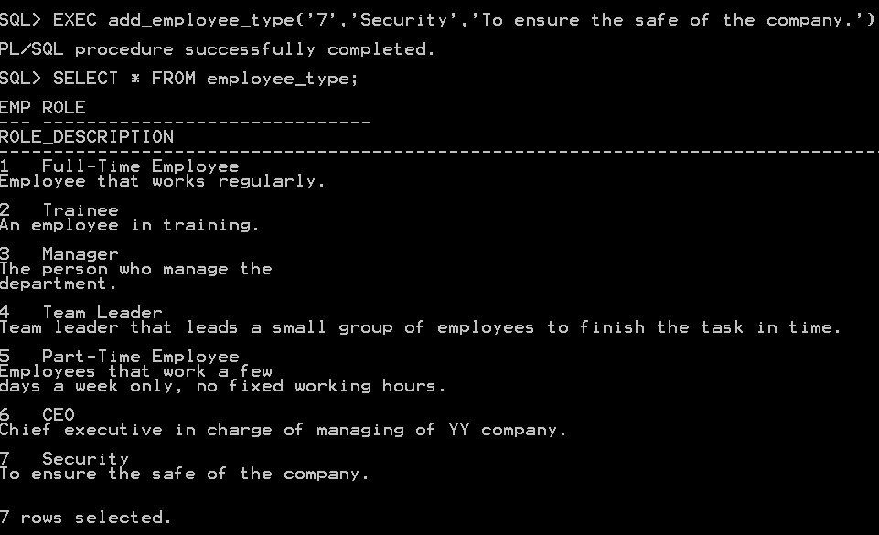

**Procedure 2:**

CREATE OR REPLACE PROCEDURE update_employee_type

(

selected_employee_type_id in VARCHAR,

new_role in VARCHAR,

new_role_description in VARCHAR)

IS BEGIN

UPDATE employee_type

SET

role=new_role,

role_description=new_role_description

WHERE employee_type_id = selected_employee_type_id;

COMMIT;

END;

/

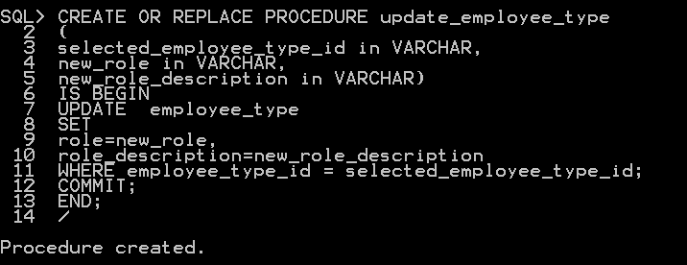

Function: Allow the user to update a selected employee type details with id.

Before using the update_employee_type procedure.

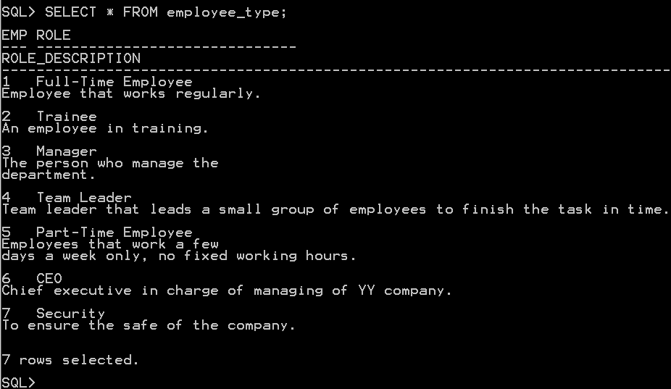

After using the update_employee_type procedure.

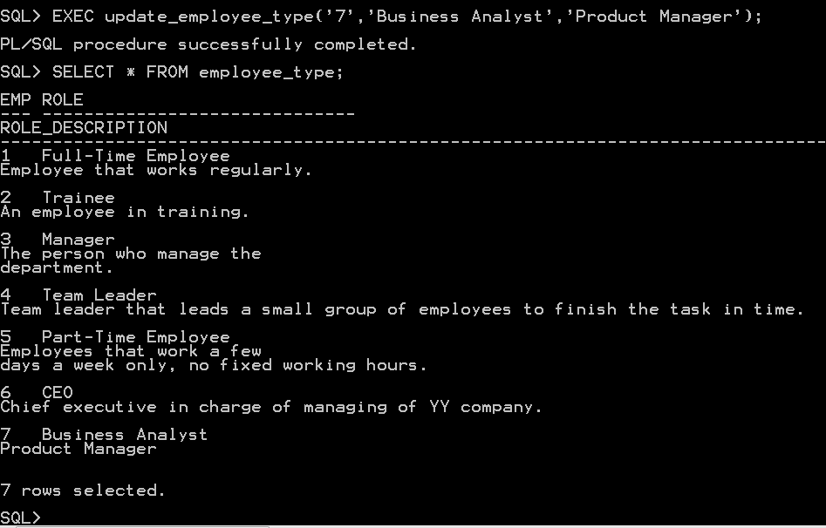

**Procedure 3:**

CREATE OR REPLACE PROCEDURE

delete_employee_type

(

selected_employee_type_id in VARCHAR

)

IS BEGIN

DELETE FROM employee_type

WHERE employee_type_id = selected_employee_type_id;

COMMIT;

END;

/

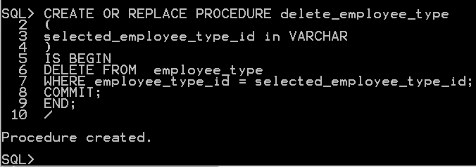

Function: Allow the user to delete a selected employee type details with id.

Before using the delete_employee_type procedure.

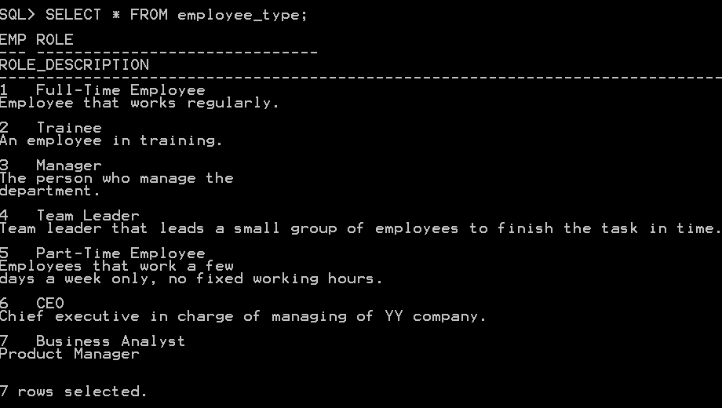

After using the delete_employee_type procedure.

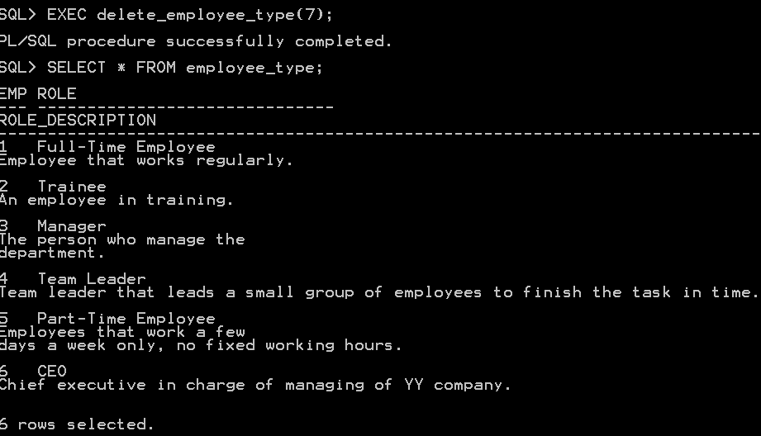

**Procedure 4:**

CREATE OR REPLACE PROCEDURE add_leave_type

(

new_leave_id in VARCHAR,

new_leave_type in VARCHAR,

new_description in VARCHAR,

new_leave_days_per_year in INT,

new_max_days_carryforward in INT)

IS BEGIN

INSERT INTO leave_type VALUES

(

new_leave_id,

new_leave_type,

new_description,

new_leave_days_per_year,

new_max_days_carryforward);

COMMIT;

END;

/

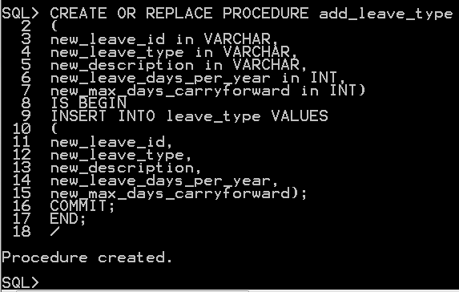

Function: Allow the user to insert new leave type into leave type table using procedure.

Before using the add_leave_type procedure.

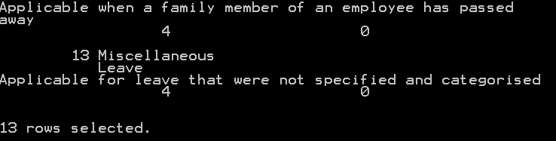

After using the add_leave_type procedure.



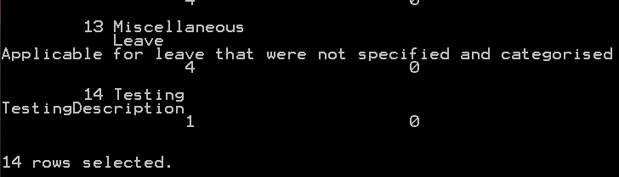

**Procedure 5:**

CREATE OR REPLACE PROCEDURE update_leave_type

(

selected_leave_id in VARCHAR,

new_leave_type in VARCHAR,

new_description in VARCHAR,

new_leave_days_per_year in INT,

new_max_days_carryforward in INT)

IS BEGIN

UPDATE leave_type

SET

leave_type=new_leave_type,

description=new_description,

leave_days_per_year=new_leave_days_per_year,

max_days_carryforward =new_max_days_carryforward

WHERE leave_id=selected_leave_id;

COMMIT;

END;

/

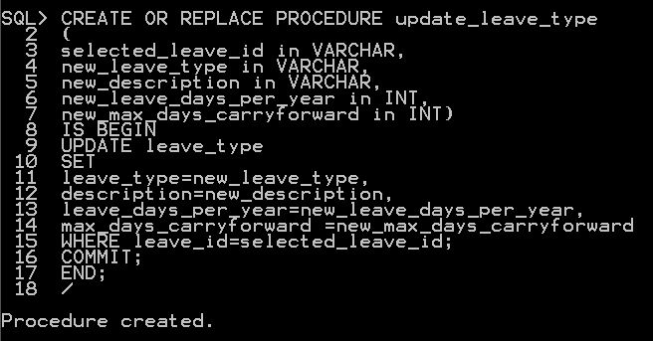

Function: Allow the user to update a selected leave type details with id.

Before using the update_leave_type procedure.



After using the update_leave_type procedure.



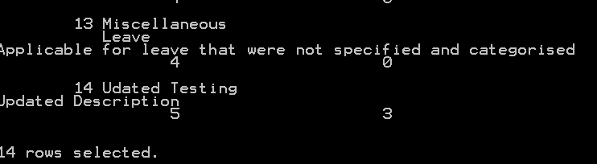

**10.3 FUNCTIONS:**

**Function 1:**

CREATE OR REPLACE FUNCTION leave_balance_type(report_type_id IN VARCHAR)

RETURN VARCHAR2

IS

type_count NUMBER;

BEGIN

SELECT COUNT(*) INTO type_count

FROM leave_balance

WHERE leave_id=report_type_id;

RETURN ('There are '||type_count||' of leave-type-id('||report_type_id||') exist in leave balance table. ');

END;

/

DECLARE

BEGIN

DBMS_OUTPUT.PUT_LINE(leave_balance_type('1'));

END;

/

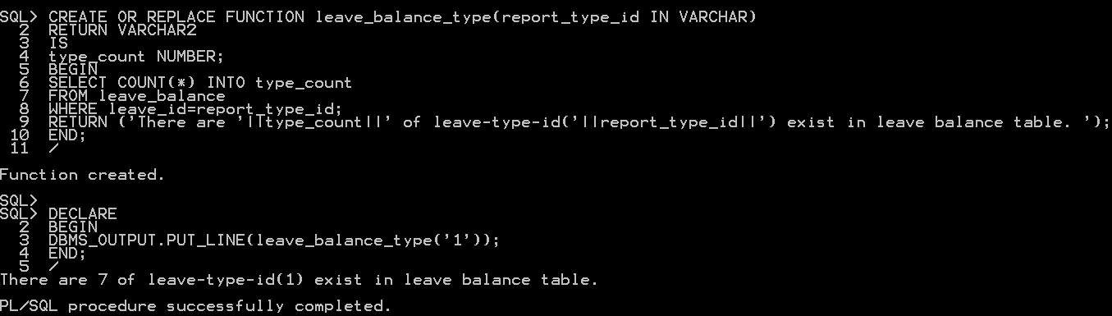

Function: Allow the user to search the number of employees by employee type id.

**Function 2:**

CREATE OR REPLACE FUNCTION report_type_count(report_type_id IN VARCHAR2)

RETURN VARCHAR2

IS

type_count NUMBER;

BEGIN

SELECT COUNT(*) INTO type_count

FROM leave_report

WHERE leave_id=report_type_id;

RETURN ('There are '||type_count||' of leave-type-id('||report_type_id||') requested in this company. ');

END;

/

DECLARE

BEGIN

DBMS_OUTPUT.PUT_LINE(report_type_count('3'));

END;

/

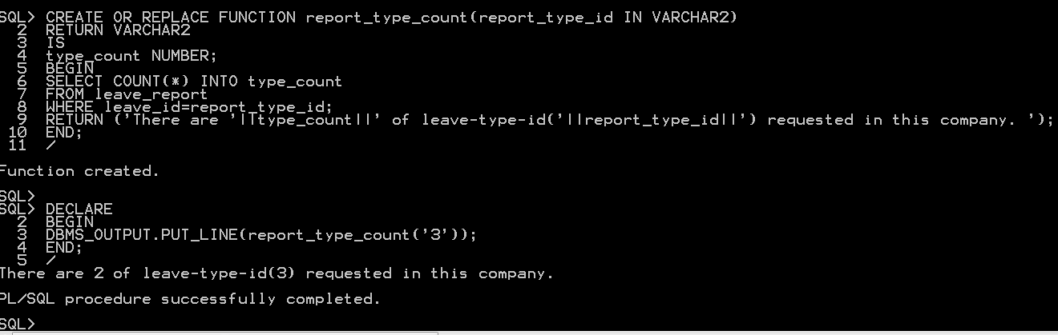

Function: Allow the user to search the times of specific leave_type requested in the leave report table.

**Function 3:**

CREATE OR REPLACE FUNCTION branch_salary(input_branch_id in VARCHAR2)

RETURN VARCHAR2

IS

total_salary NUMBER;

BEGIN

SELECT SUM(salary) INTO total_salary FROM employee

WHERE branch_id = input_branch_id;

RETURN('The monthly paid of this branch is RM'||total_salary||'. ');

END;

/

DECLARE

BEGIN

DBMS_OUTPUT.PUT_LINE(branch_salary('B'));

END;

/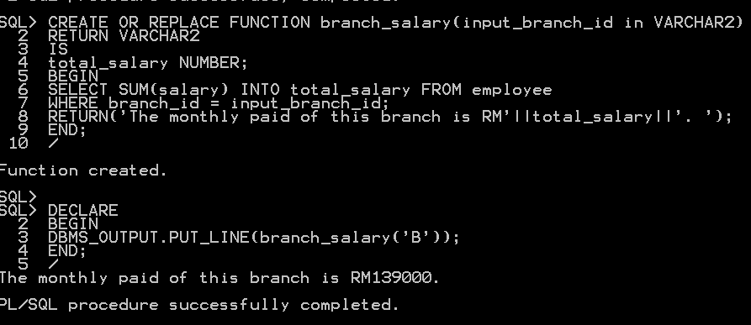Function: Allow the user to get the total paid to the branch per month.

**Function 4:**

CREATE OR REPLACE FUNCTION employee_year_salary(emp_id in VARCHAR2)

RETURN VARCHAR2

IS

total_salary NUMBER;

BEGIN

SELECT salary*12 INTO total_salary FROM employee

WHERE employee_id = emp_id;

RETURN('Employee earn RM'||total_salary||' per year . ');

END;

/

DECLARE

BEGIN

DBMS_OUTPUT.PUT_LINE(employee_year_salary('A10001'));

END;

/

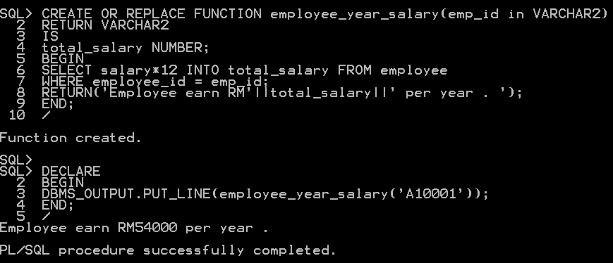

Function: Allow the user to get the total salary per year of a specified employee.

**Function 5:**

CREATE OR REPLACE FUNCTION emp_type_count(emp_type_id in VARCHAR2)

RETURN VARCHAR2

IS

emp_count NUMBER;

BEGIN

SELECT COUNT(*) INTO emp_count

FROM employee

WHERE employee_type_id=emp_type_id;

RETURN('There is '||emp_count||' of type-id('|| emp_type_id ||') employees in this company . ');

END;

/

DECLARE

BEGIN

DBMS_OUTPUT.PUT_LINE(emp_type_count ('1'));

END;

/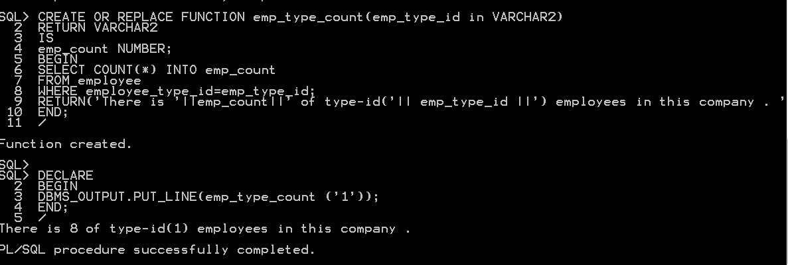Function: Allow the user to get the number of employees with specified employee_type id.

**11.0 Individual Assessment (TAN JIA YONG 17ACB03508)**

**11.1 QUERIES**

**Query 1**

DESC leave_report;

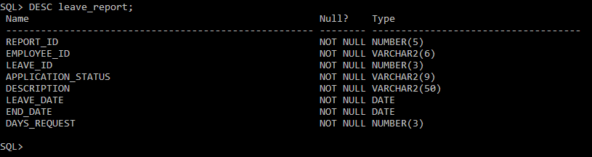

**Function:** View the information of the attribute name and datatype of leave_report table.

**Query 2**

ALTER table leave_report

MODIFY (description varchar2(50));

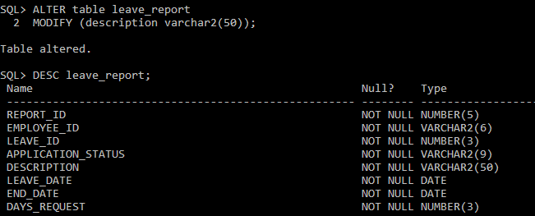

**Function:** The query is able to modify the length of description column so that it can fit the data size.

**Query 3**

INSERT INTO leave_report

VALUES('13','A10007','1','PENDING','Reason not given', date '2020-03-19',date '2020-03-20','2');

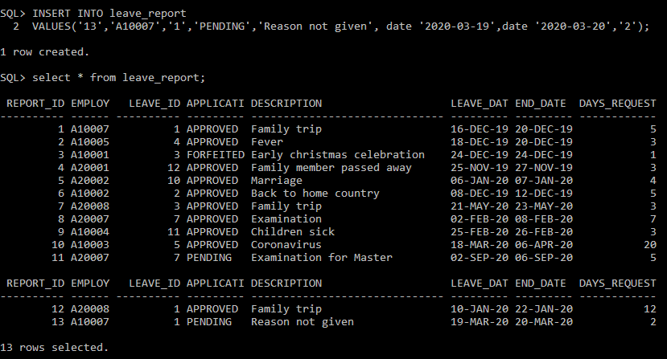

**Function:** Insert new Leave report into the table.

**Query 4**

UPDATE leave_report

SET application_status = 'APPROVED'

WHERE report_id = 13;

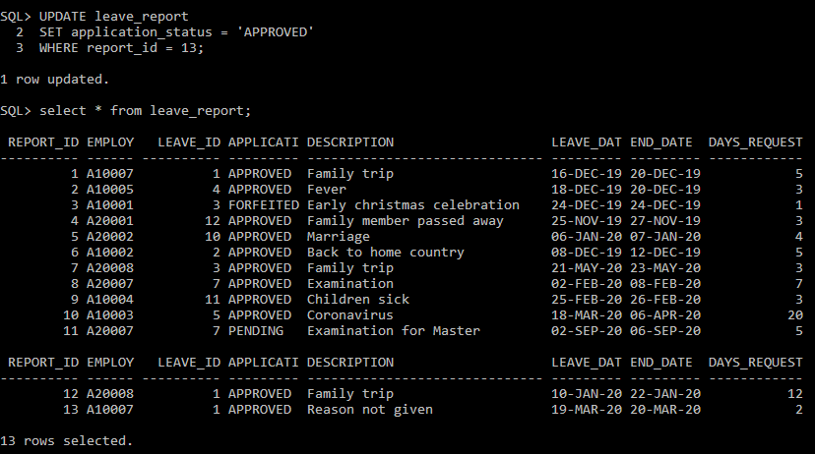

**Function:** The query can update the status of application_status.

**Query 5**

SELECT * from leave_report

ORDER BY leave_date;

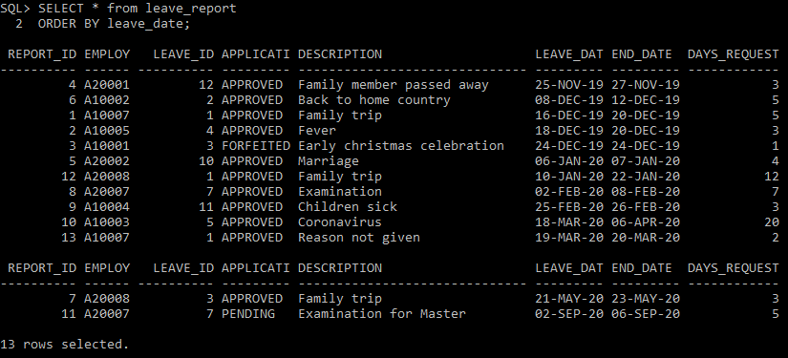

**Function:** The query will sort the records in ascending order based on leave_date.

**Query 6**

SELECT * from leave_report

WHERE application_status = 'PENDING';

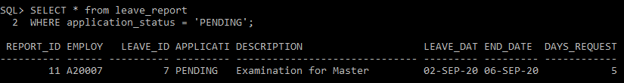

**Function:** The query will display the record with PENDING status on application_status.

**Query 7**

SELECT r.report_id, r.employee_id, t.leave_type, r.application_status, r.description

FROM leave_report r LEFT OUTER JOIN leave_type t

ON (r.leave_id =t.leave_id)

ORDER BY report_id;

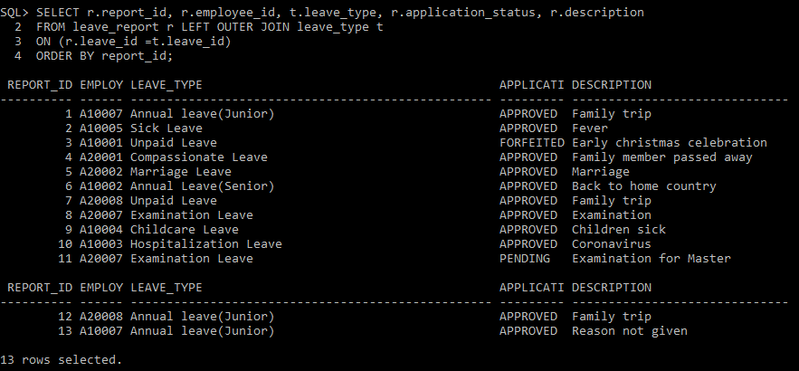

**Function:** The query will replace the leave_id with leave_type so that we know exactly which leave is requested.

**Query 8**

SELECT e.name, SUM(r.days_request) as "TOTAL_DAYS_REQUEST"

FROM leave_report r LEFT JOIN employee e

ON (r.employee_id = e.employee_id)

GROUP BY name

ORDER BY TOTAL_DAYS_REQUEST DESC;

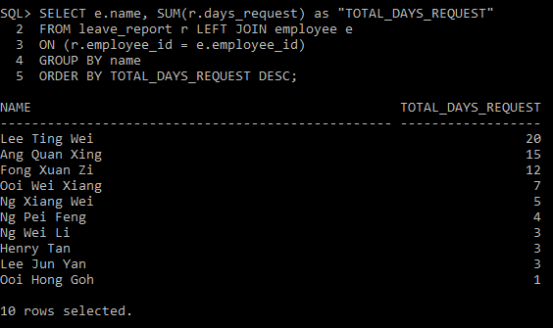

**Function:** The query will show the total day requested by each employee based on leave_report table.

**Query 9**

SELECT t.leave_type, COUNT(r.leave_id) as "NUM_OF_LEAVE_REQUESTED"

FROM leave_report r JOIN leave_type t

ON (r.leave_id =t.leave_id)

GROUP BY leave_type

ORDER BY NUM_OF_LEAVE_REQUESTED DESC;

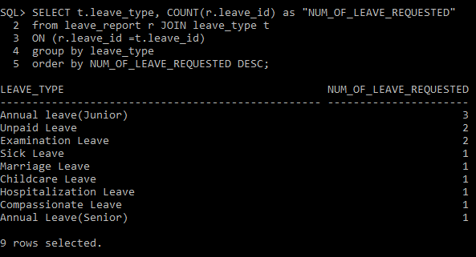

**Function:** The query will show the total number of leave requested and leave_type based on leave_report.

**Query 10**

CREATE OR REPLACE VIEW leave_report_view AS

SELECT * FROM leave_report

WITH READ ONLY;

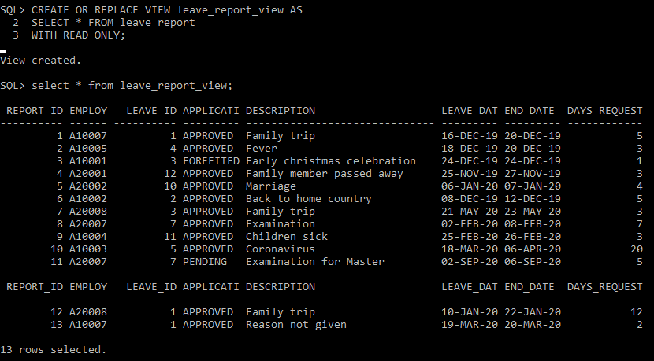

**Function:** The query will create a view for user to view the table and are not able to edit the record.

**11.2 STORED PROCEDURES**

**Procedure 1:**

CREATE OR REPLACE PROCEDURE add_report

(new_report_id in number, new_employee_id in varchar2, new_leave_id in number,

new_application_status in varchar2, new_description in varchar2,

new_leave_date in date, new_end_date in date, new_days_request in number)

IS BEGIN

INSERT INTO leave_report

VALUES(new_report_id, new_employee_id, new_leave_id,new_application_status,

new_description, new_leave_date, new_end_date, new_days_request);

COMMIT;

END;

/

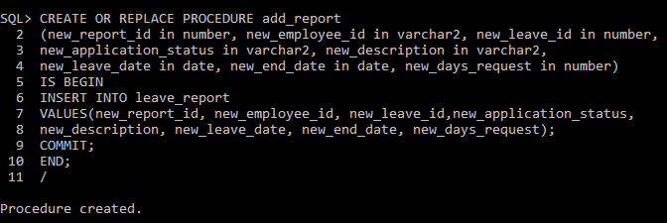

**Function:** Allow users to add new leave report into leave_report using procedure.

After executing the procedure. The record is added into leave_report.

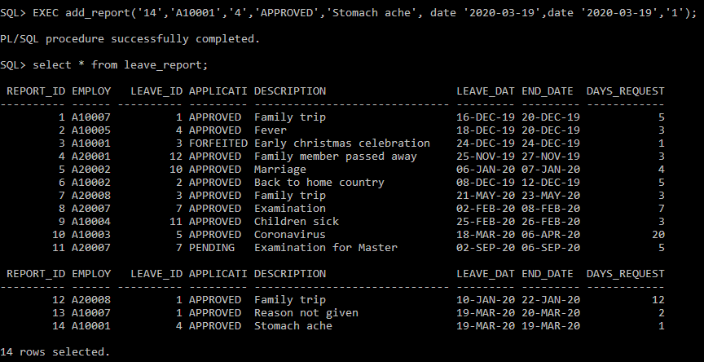

**Procedure 2:**

CREATE OR REPLACE PROCEDURE update_application_status

(selected_report_id in number, new_application_status in varchar2)

IS BEGIN

UPDATE leave_report

SET application_status = new_application_status

WHERE report_id = selected_report_id;

COMMIT;

END;

/

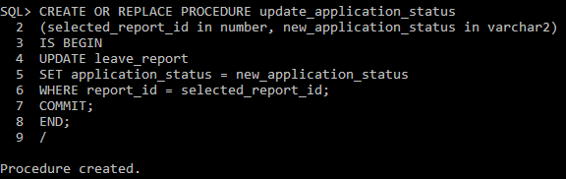

**Function:** Allow users to update the status of application_status using procedure.

After executing the procedure. The status of report_id ‘14’ is updated.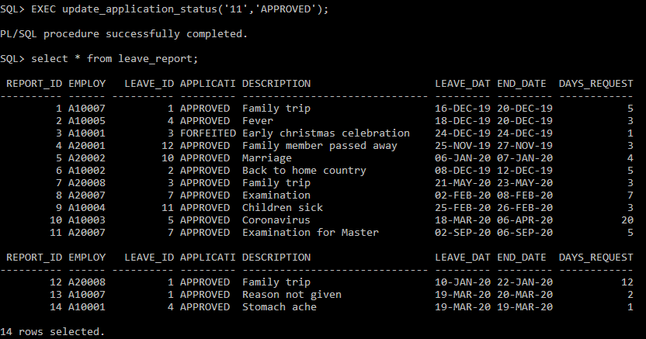

**Procedure 3:**

CREATE OR REPLACE PROCEDURE delete_report

(selected_report_id in number)

IS BEGIN

DELETE FROM leave_report

WHERE report_id = selected_report_id;

COMMIT;

END;

/

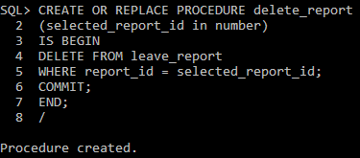

**Function:** Allow users to delete the leave report using procedure.

After executing the procedure, the leave report_id ‘14’ is deleted from the table.

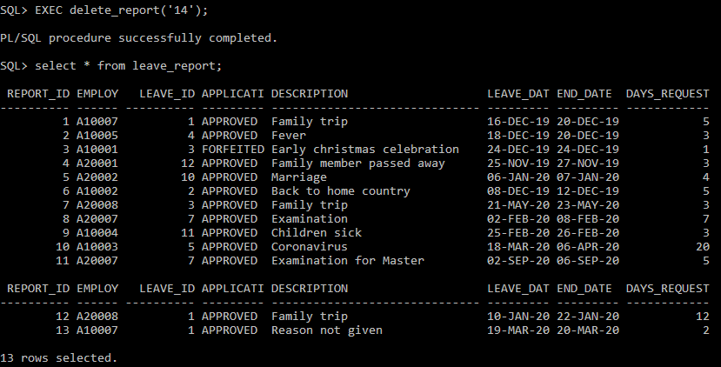

**Procedure 4:**

CREATE OR REPLACE PROCEDURE update_leave_date

(selected_report_id in number, new_leave_date in date,

new_end_date in date, new_days_request in number)

IS BEGIN

UPDATE leave_report

SET leave_date = new_leave_date,

end_date = new_end_date, days_request = new_days_request

WHERE report_id = selected_report_id;

COMMIT;

END;

/

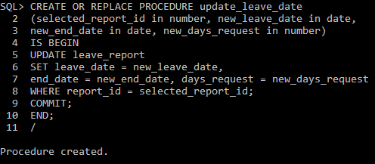

**Function:** Allow users to update the leave_date,end_date and days_request using procedure.

After executing the procedure, the leave_date of report_id ‘13’ is updated.

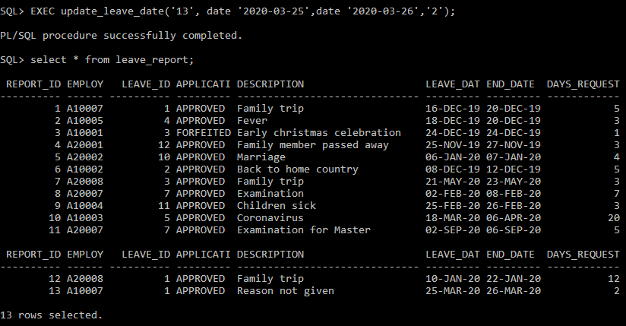

**Procedure 5:**

CREATE OR REPLACE PROCEDURE update_description

(selected_report_id in number, new_description in varchar2)

IS BEGIN

UPDATE leave_report

SET description = new_description

WHERE report_id = selected_report_id;

COMMIT;

END;

/

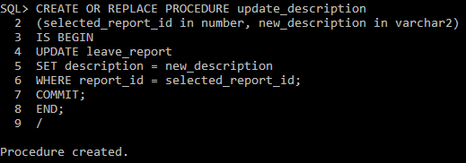

**Function:** Allow users to update the description of leave_report using procedure.

After executing the procedure, the description of report_id ‘13’ is updated.

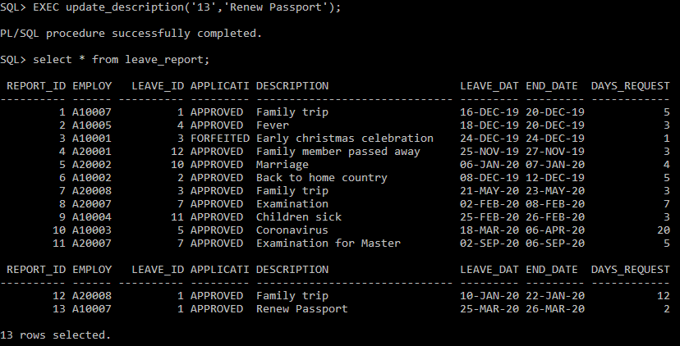

**11.3 FUNCTIONS**

**Function 1:**

CREATE OR REPLACE FUNCTION average_day_request(input_leave_id in VARCHAR2)

RETURN VARCHAR2

IS

average NUMBER;

BEGIN

SELECT ROUND(AVG(days_request)) INTO average FROM leave_report

WHERE leave_id = input_leave_id;

RETURN('The average day requested of this leave_id is '||average||' Day. ');

END;

/

DECLARE

BEGIN

DBMS_OUTPUT.PUT_LINE(average_day_request('1'));

END;

/

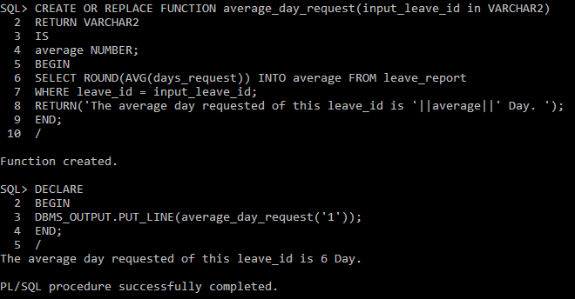

**Function:** The user can find the average day request of a type of leave by executing this function and inputting the leave_id.

**Function 2:**

CREATE OR REPLACE FUNCTION total_day_request(input_employee_id in VARCHAR2)

RETURN VARCHAR2

IS

total NUMBER;

BEGIN

SELECT SUM(days_request) INTO total FROM leave_report

WHERE employee_id = input_employee_id;

RETURN('The total day requested by '||input_employee_id||' is '||total||' Day. ');

END;

/

DECLARE

BEGIN

DBMS_OUTPUT.PUT_LINE(total_day_request('A10007'));

END;

/

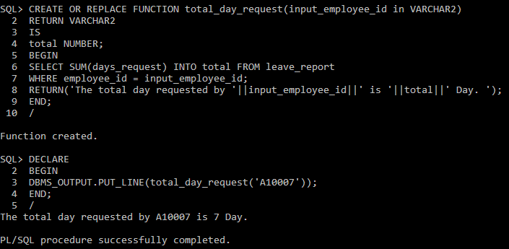

**Function:** The user can find the total day requested by a certain employee by executing this function and inputting the employee_id.

**Function 3:**

CREATE OR REPLACE FUNCTION check_days

RETURN VARCHAR2

IS

A NUMBER;

B NUMBER;

BEGIN

SELECT SUM(days_request) INTO A FROM leave_report;

SELECT SUM(end_date-leave_date+1) INTO B FROM leave_report;

IF B=A THEN

RETURN('The Date and Day Requested is correct.');

ELSE

RETURN('The Date and Day Requested is not correct.');

END IF;

END;

/

DECLARE

BEGIN

DBMS_OUTPUT.PUT_LINE(check_days());

END;

/

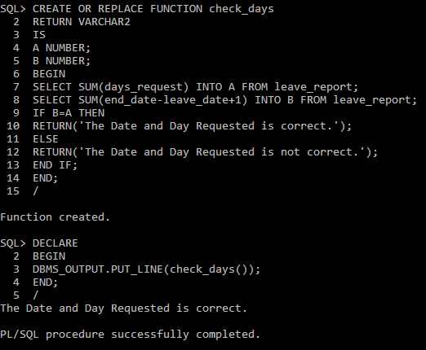

**Function:** The user can check whether the days_request and the date is tally by executing this function.

**Function 4:**

CREATE OR REPLACE FUNCTION total_report_emp(input_employee_id in VARCHAR2)

RETURN VARCHAR2

IS

total NUMBER;

BEGIN

SELECT COUNT(report_id) INTO total FROM leave_report

WHERE employee_id = input_employee_id;

RETURN('The total number of leave report by '||input_employee_id||' is '||total||' .');

END;

/

DECLARE

BEGIN

DBMS_OUTPUT.PUT_LINE(total_report_emp('A20007'));

END;

/

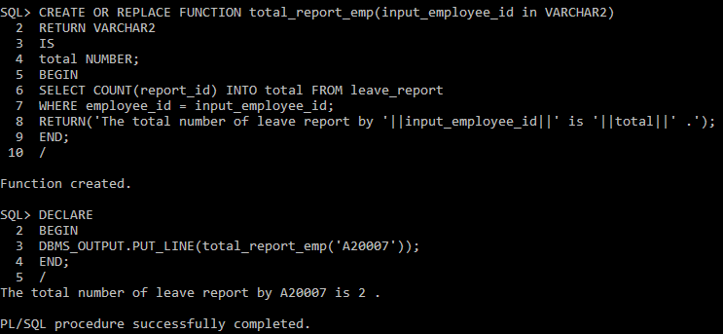

**Function:** The user can find the total number of leave reports made by a certain employee by executing this function.

**Function 5:**

CREATE OR REPLACE FUNCTION check_total_status

RETURN VARCHAR2

IS

A NUMBER;

F NUMBER;

P NUMBER;

BEGIN

SELECT COUNT(application_status) INTO A FROM leave_report

WHERE application_status = 'APPROVED';

SELECT COUNT(application_status) INTO P FROM leave_report

WHERE application_status = 'PENDING';

SELECT COUNT(application_status) INTO F FROM leave_report

WHERE application_status = 'FORFEITED';

RETURN('Total APPROVED : '||A||'

Total PENDING : '||P||'

Total FORFEITED : '||F||' ');

END;

/

DECLARE

BEGIN

DBMS_OUTPUT.PUT_LINE(check_total_status);

END;

/

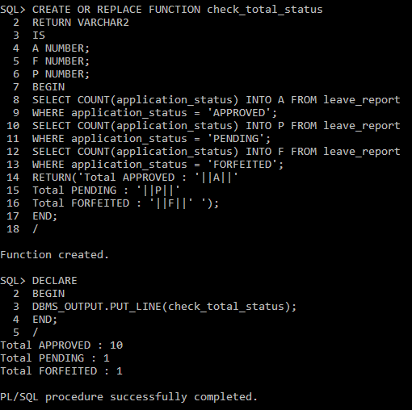

**Function:** The user can check the total number of application status by executing this function.